# **Appendix**

**SAS codes and plots for Analysis of Question 1:**

Importing Train.csv and Test.csv datasets and naming them IMORT and IMPORT1 on SAS on demand:

proc print data=IMPORT;

run;

proc print data=IMPORT1;

run;

There are 1460 observations and 81 variables in the train.csv and 1459 observations and 80 variables in the test.csv. Create a new dataset “trainNew” with only 3 neighborhoods NAmes, BrkSide and Edwards:

data trainnew;

set IMPORT;

where neighborhood ="NAmes" OR neighborhood = "BrkSide" OR neighborhood = "Edwards";

run;

The output is filtering the dataset to just 383 observations and 81 variables, then;

proc print data = trainnew;

run;

The output is filtering the dataset to just 383 observations and 83 variables:

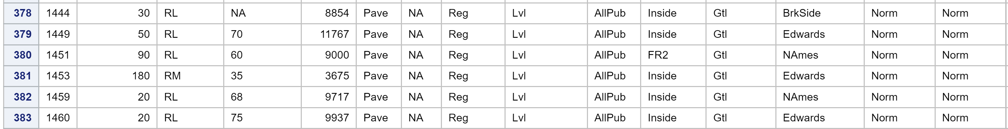

**Scatterplot for SalePrice Vs. GrLivArea:**

title ‘Scatter plot: SalePrice v. GrLIvArea’;

PROC sgplot DATA=trainnew;

scatter x=GrLIvArea y=SalePrice;

run;

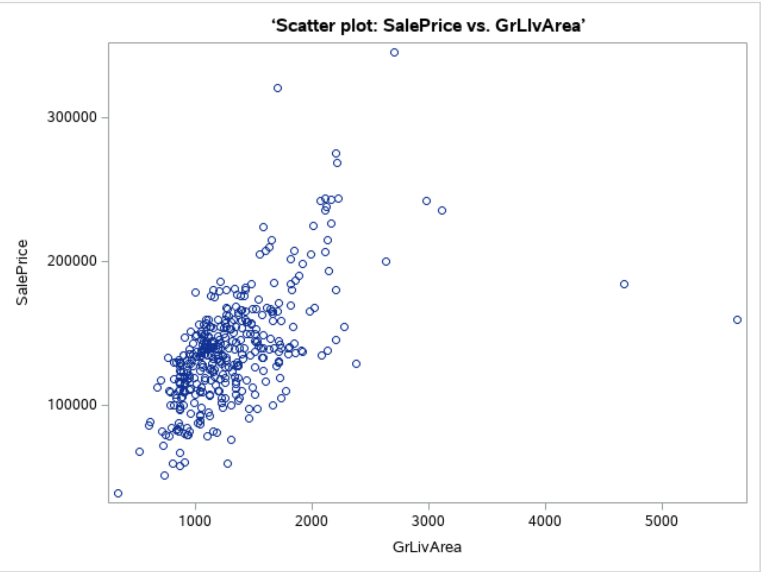

**PLOT 1**

There are some outliers ($ Outliers) on the larger living areas but there is also a linear relation between those two.

**Build the Model 1**

*MuSalesPrice = ß0 + ß1 *(GrLivArea)*

proc reg data= trainnew;

model SalePrice = GrLIvArea / vif clb cli clm;

run;

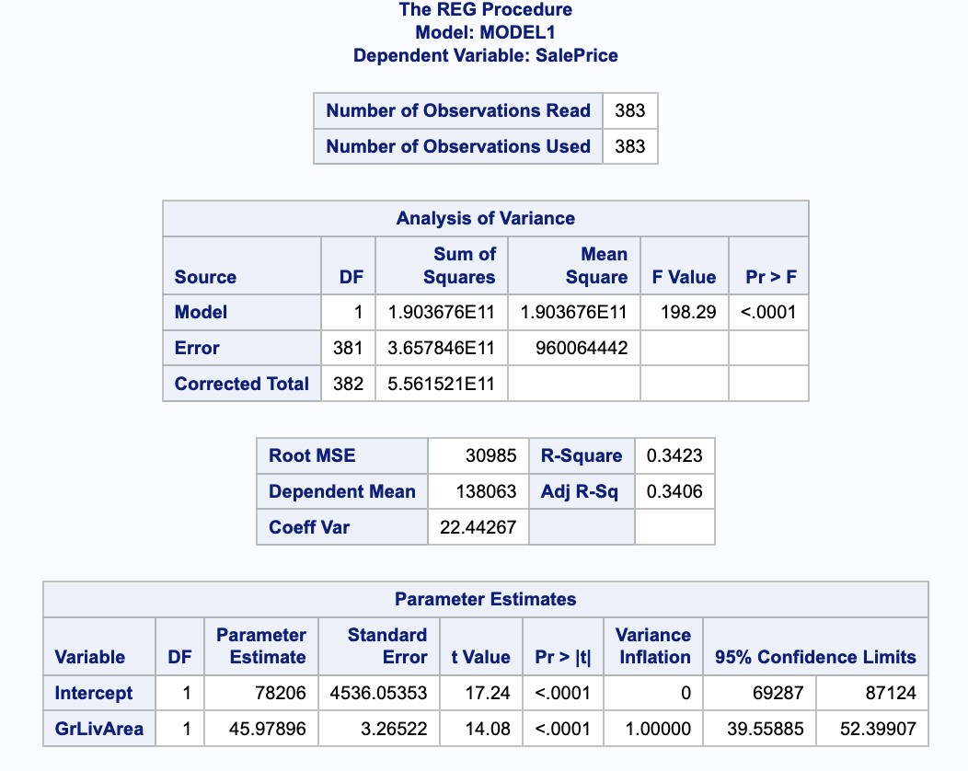 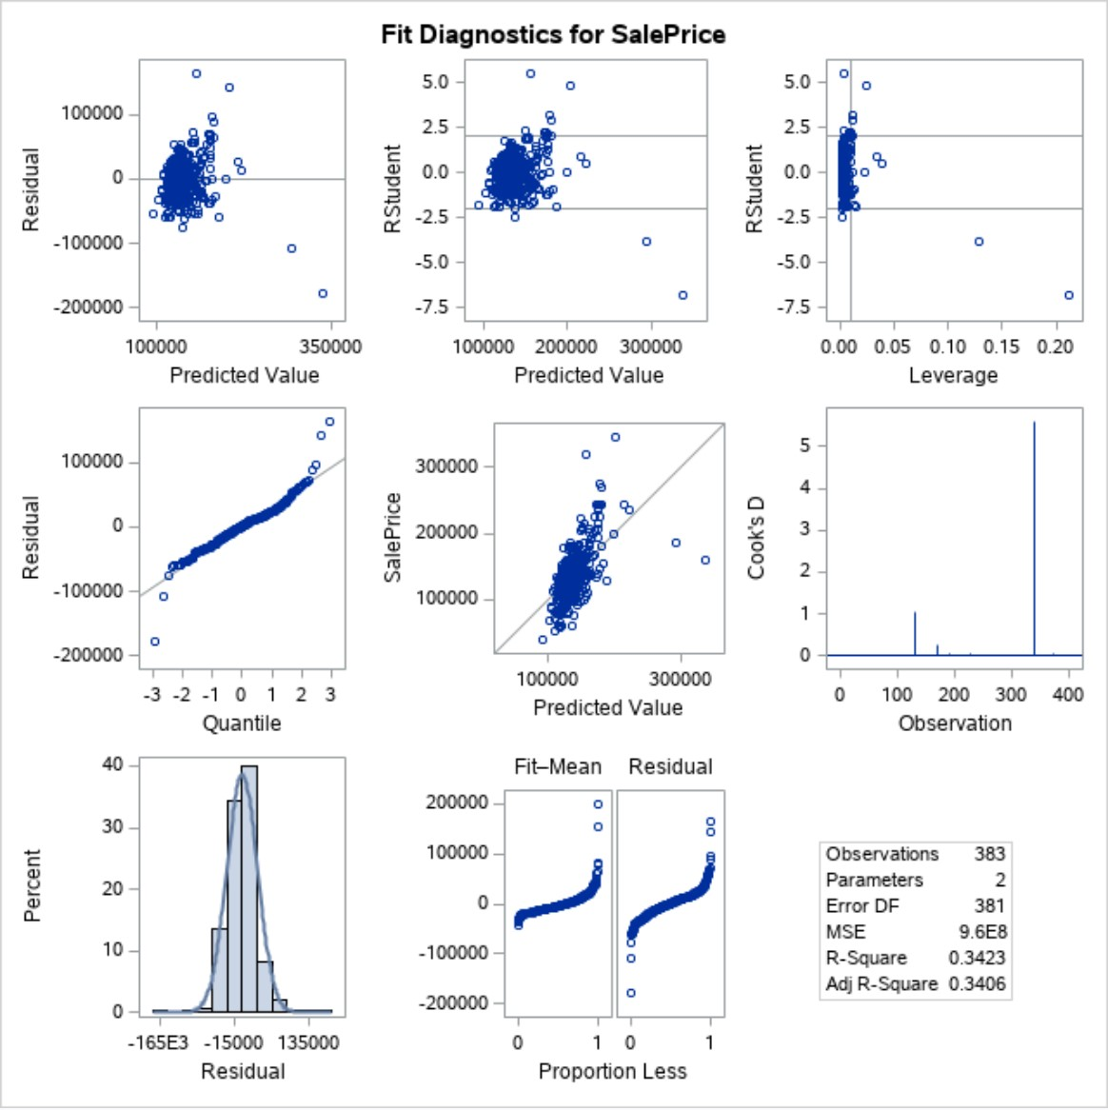

**PLOT 2**

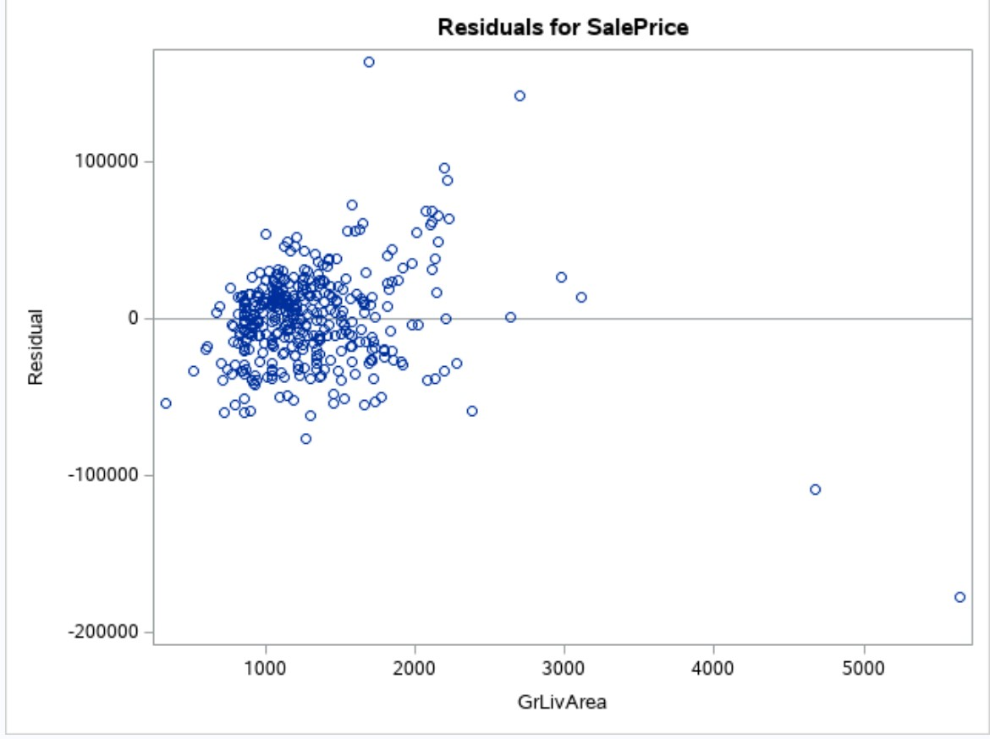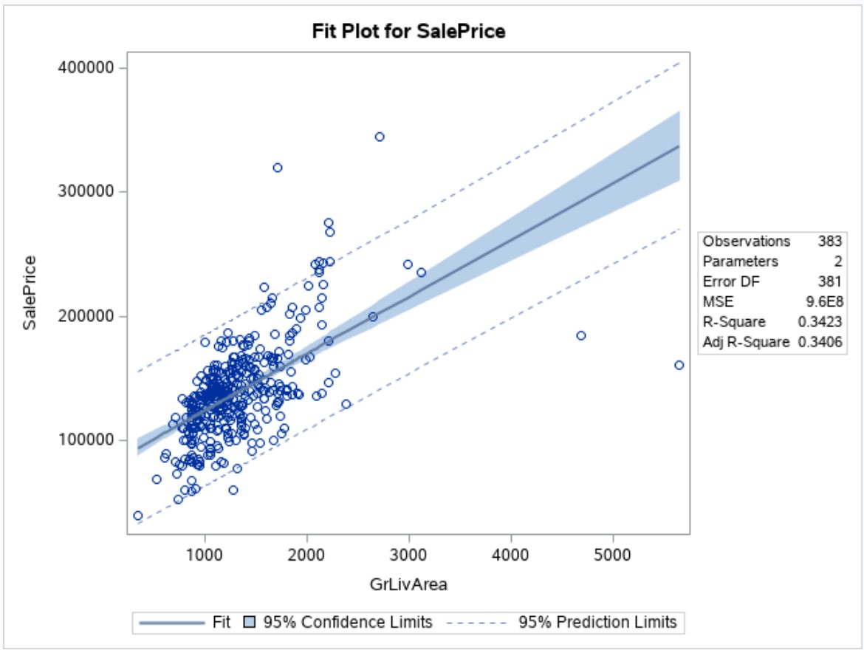

As we can see there are 4 outliers and we will be removing those;

data trainnewoutlier;

set trainnew;

where Id = 643 or Id=725 OR Id=1299 or Id=524;

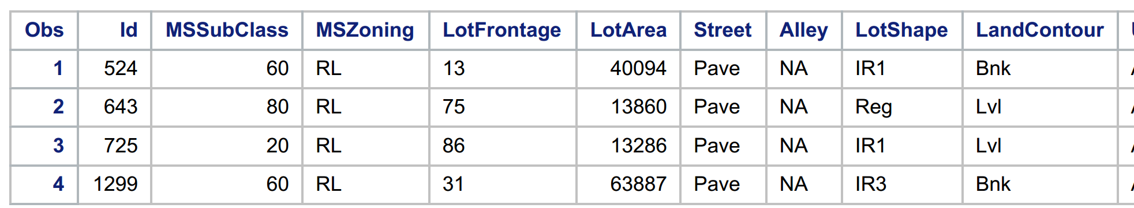

data trainnewremovedoutlier;

set trainnew;

where Id~ = 643 AND Id~=725 AND Id~=1299 AND Id~=524;

proc print data = trainnewremovedoutlier;

run;

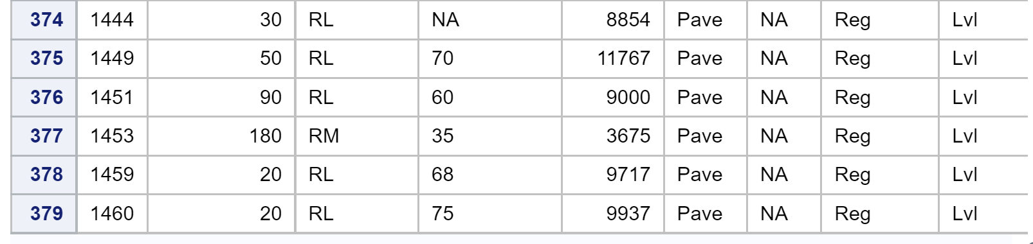

The new data set with removing the 4 outliers have 379 observations (383-4=379)

Now we plotting the new data set:

title ‘Scatter plot after removed ouliers: SalePrice vs. GrLIvArea’;

PROC sgplot DATA=trainnewremovedoutlier;

scatter x=GrLIvArea y=SalePrice;

run;

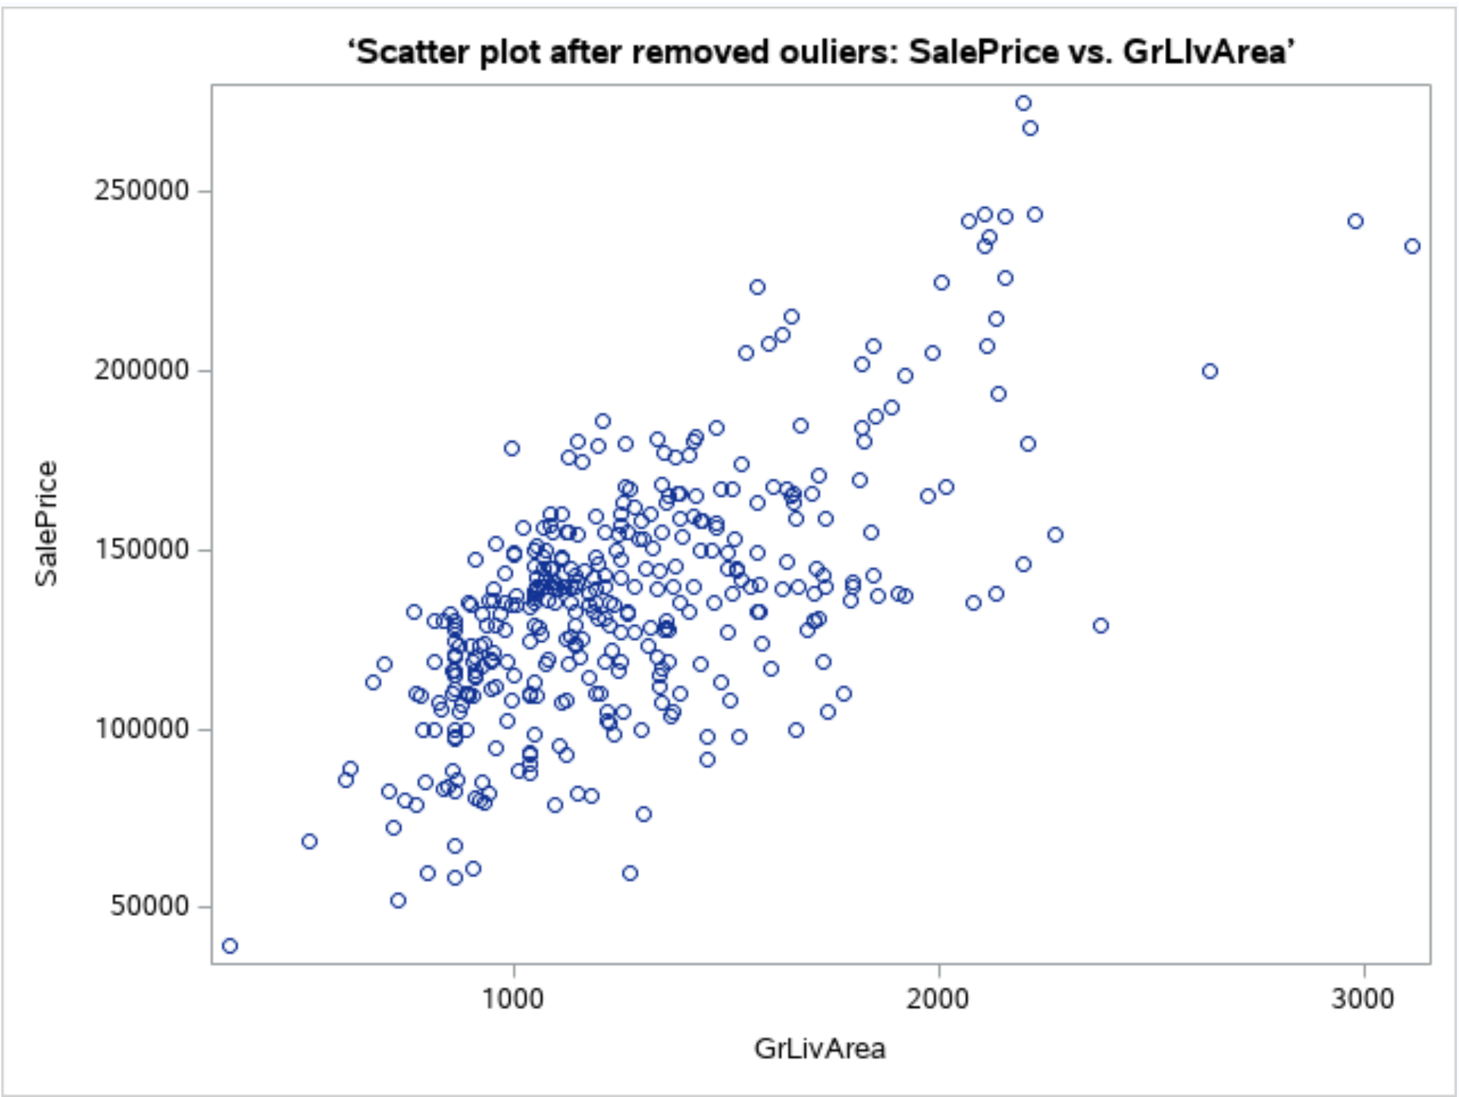

**PLOT 3**

**Build the Model 2**

This Model is without those 4 outliers.

proc reg data= trainnewremovedoutlier;

model SalePrice = GrLIvArea / vif clb cli clm;

run;

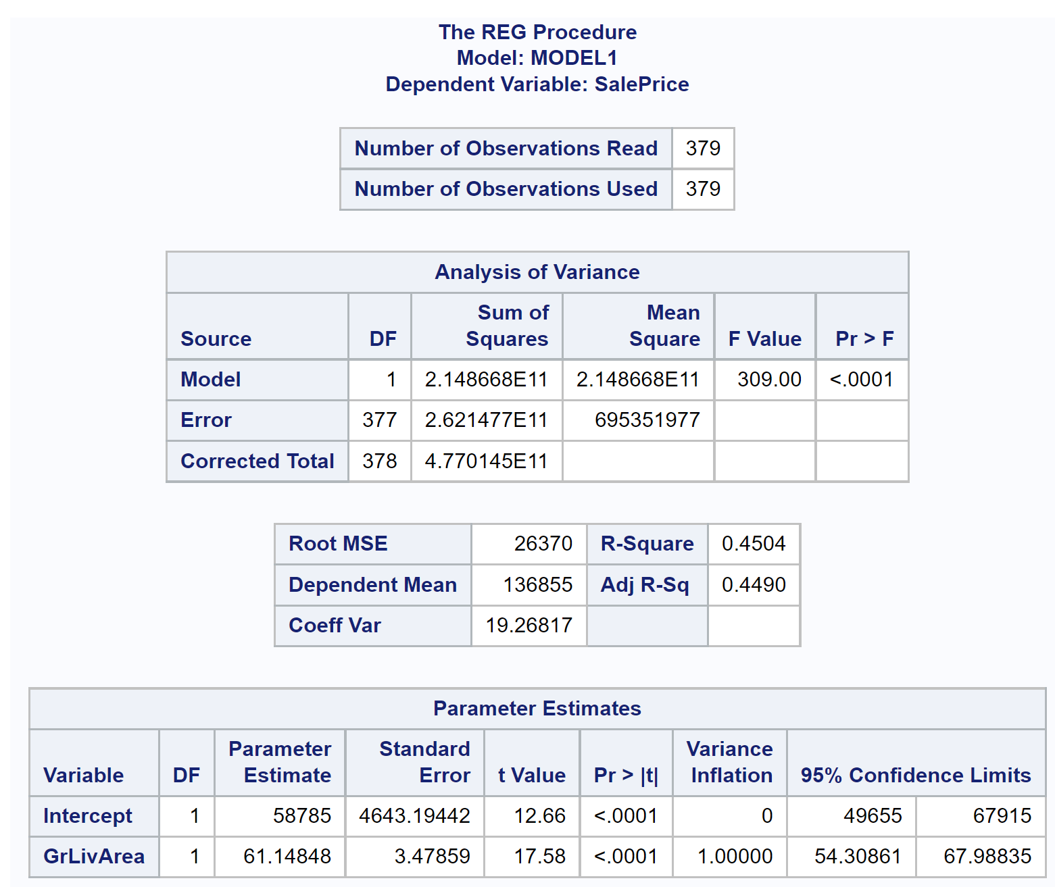

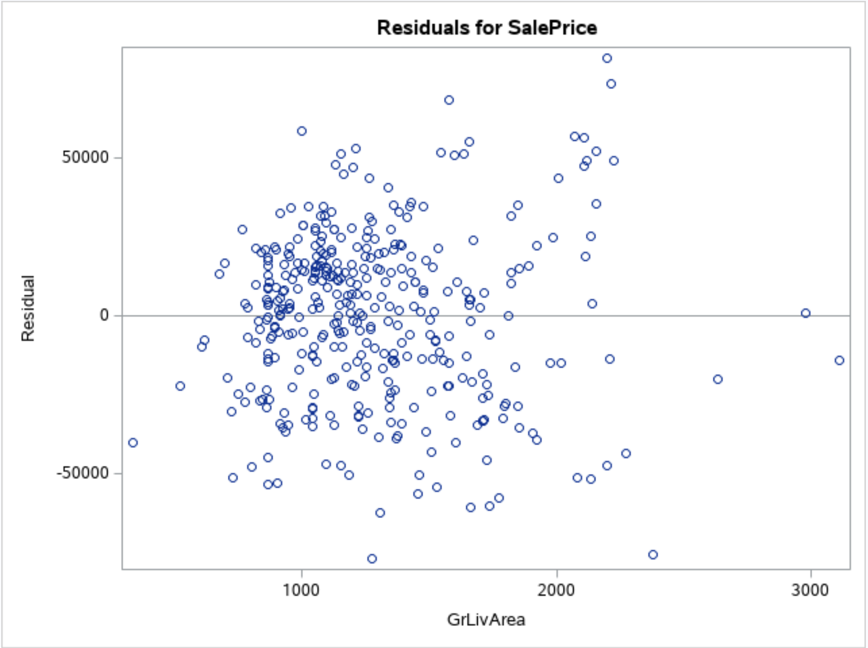 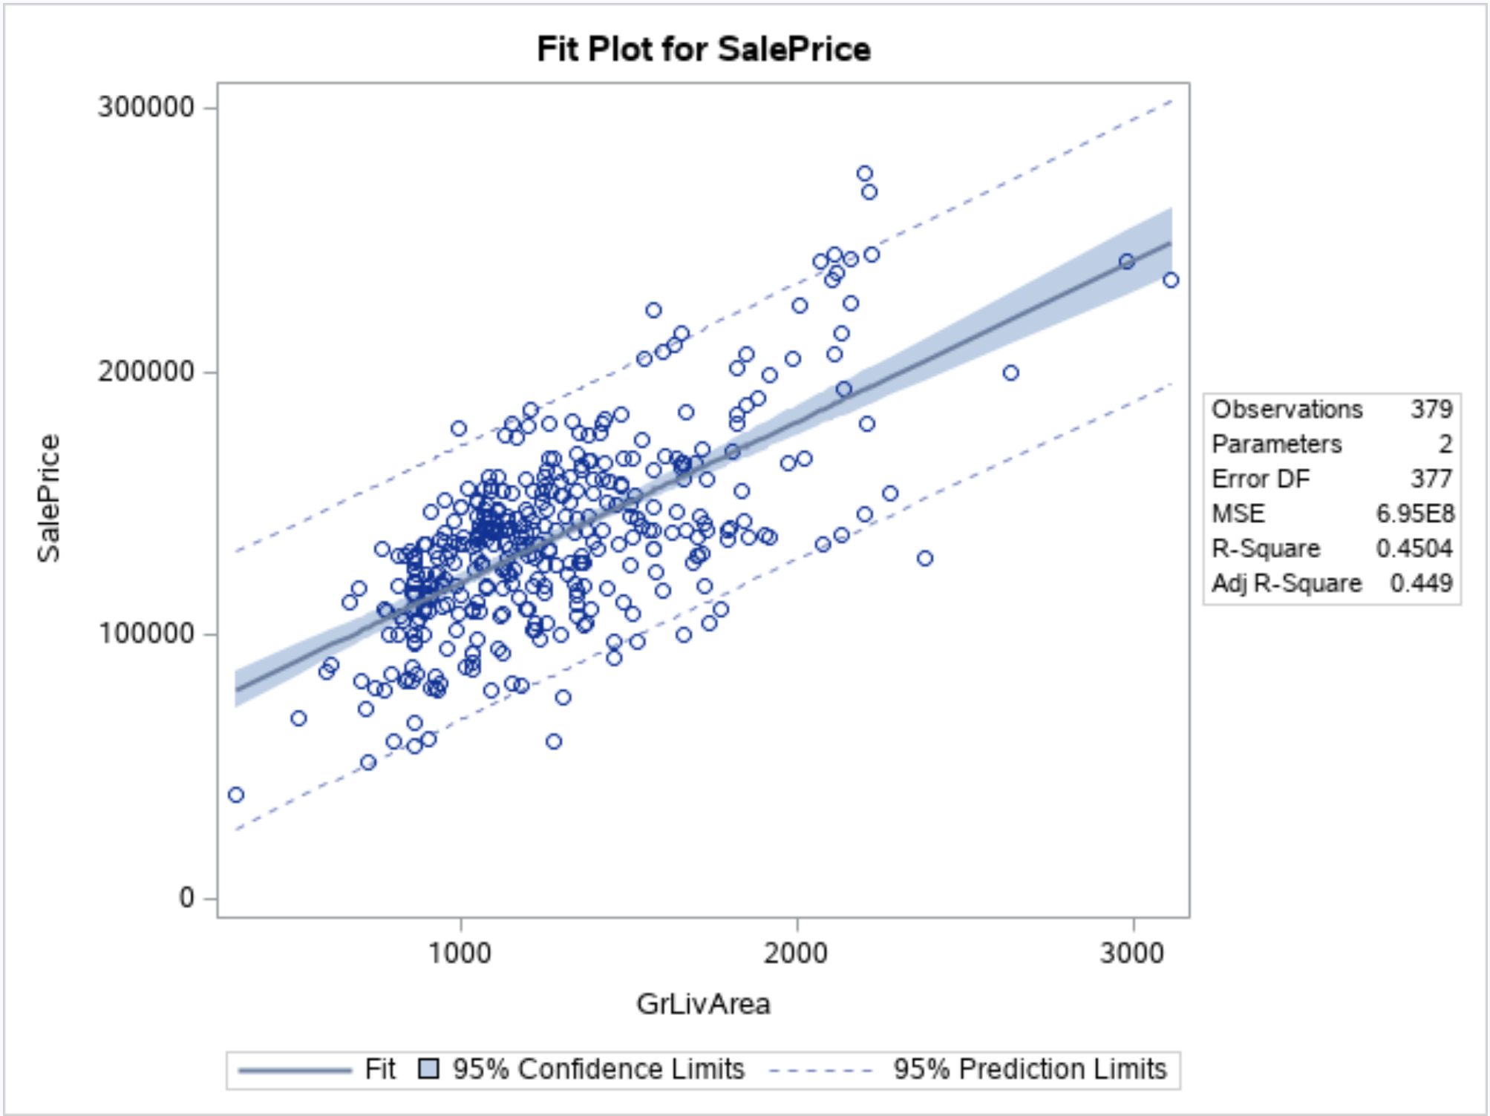

**PLOT 4**

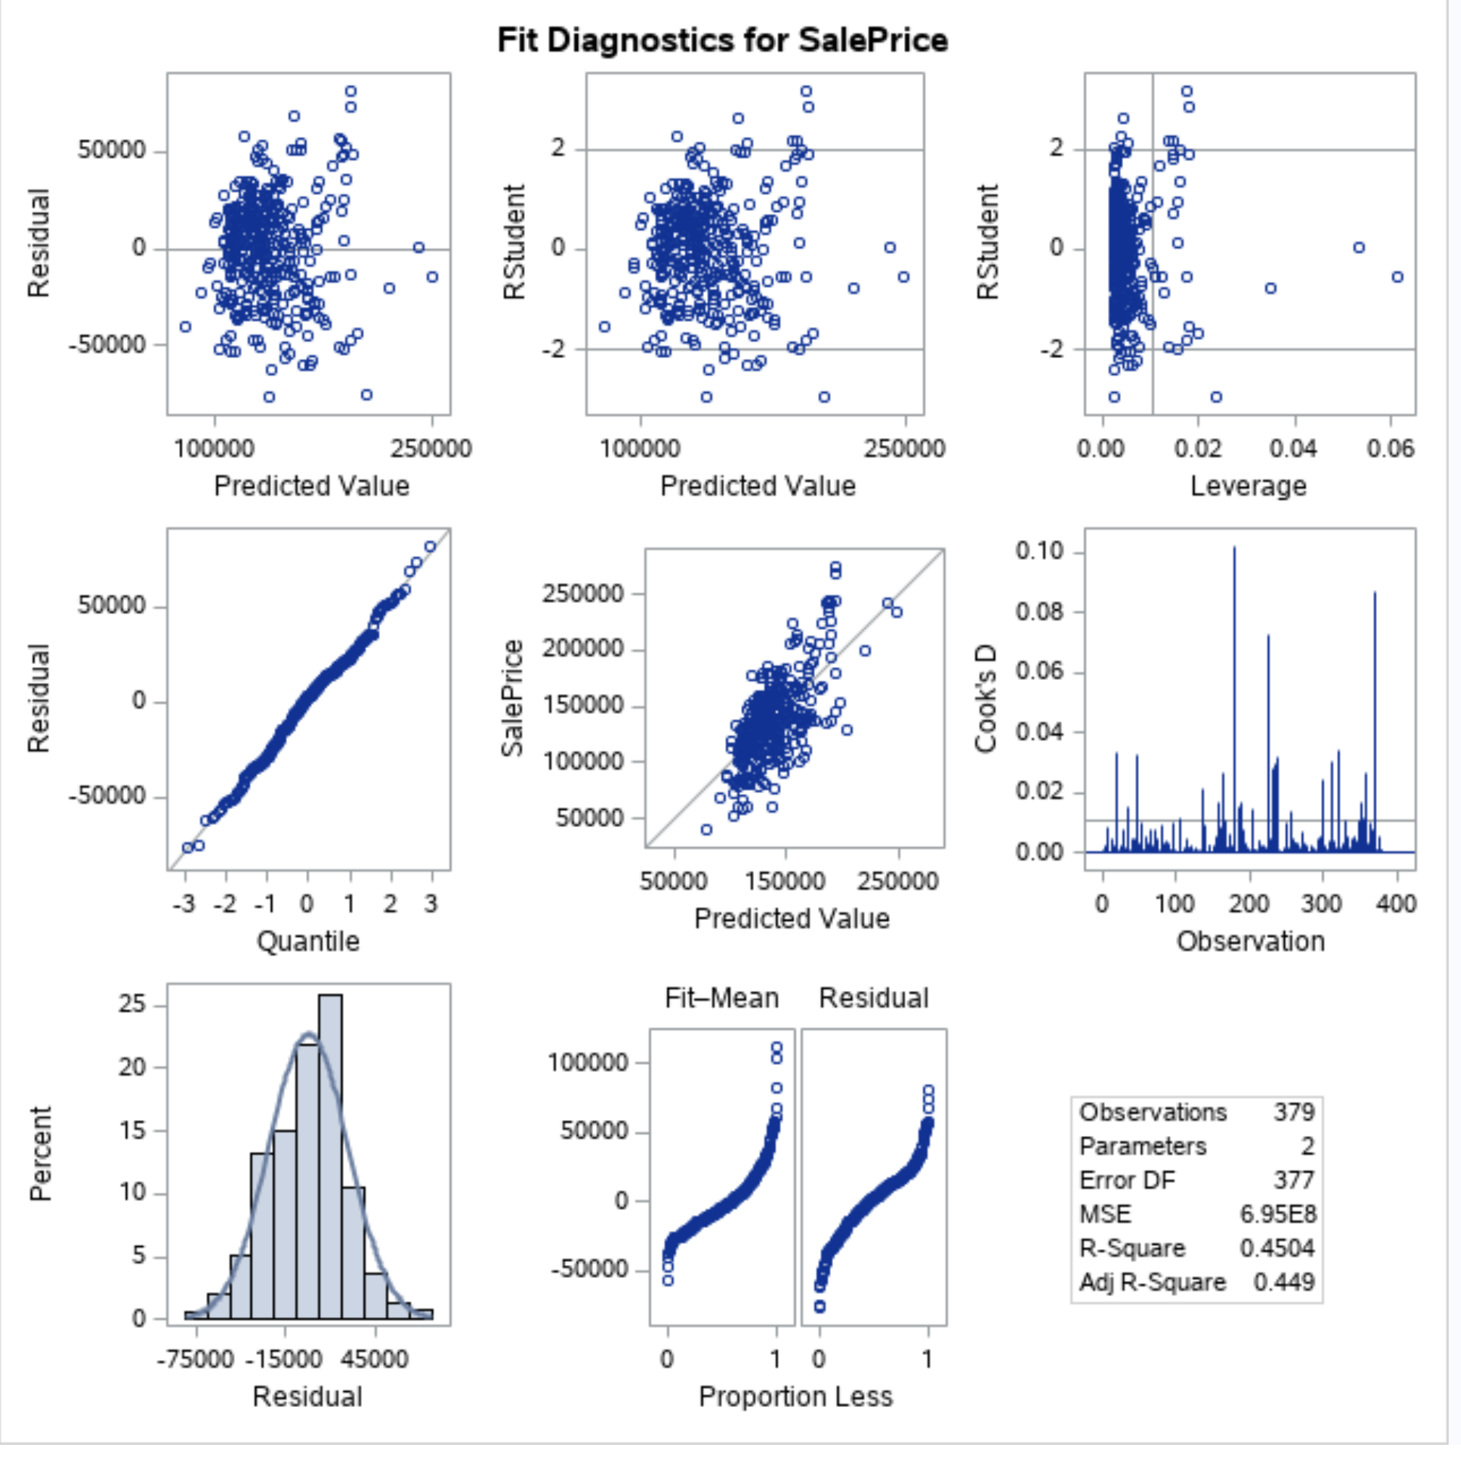

**PLOT 5**

Now we can observe a random cloud distributed along the residual line while the Cook’s D value is not higher than 0.1 so no major high leverage or high residual point. Adj R-Sq is 0.4490 which is higher than model 2, by adding in Neighborhoods, our model is better explained. So we will move forward to interpret Model 3.. QQ plot shows beautiful straight line with good shape on histogram plot. All indicating the normal distribution.

**Build the Model 3**

Build the third model without those 4 outliers also converting the living area in increments of 100 sq. ft and log Transform the SalesPrice and GrLivAreaper100 to re-run model.

data logtrain3;

set trainnewremovedoutlier;

GrLivAreaper100 =GrLIvArea/100;

logSalePrice = log(SalePrice);

logGrLIvAreaper100 = log(GrLIvArea/100);

run;

proc print data=logtrain3;

run;

Now plotting the Three neighborhoods;

proc sgplot DATA=logtrain3;

scatter x=GrLivAreaper100 y=SalePrice / group=Neighborhood;

run;

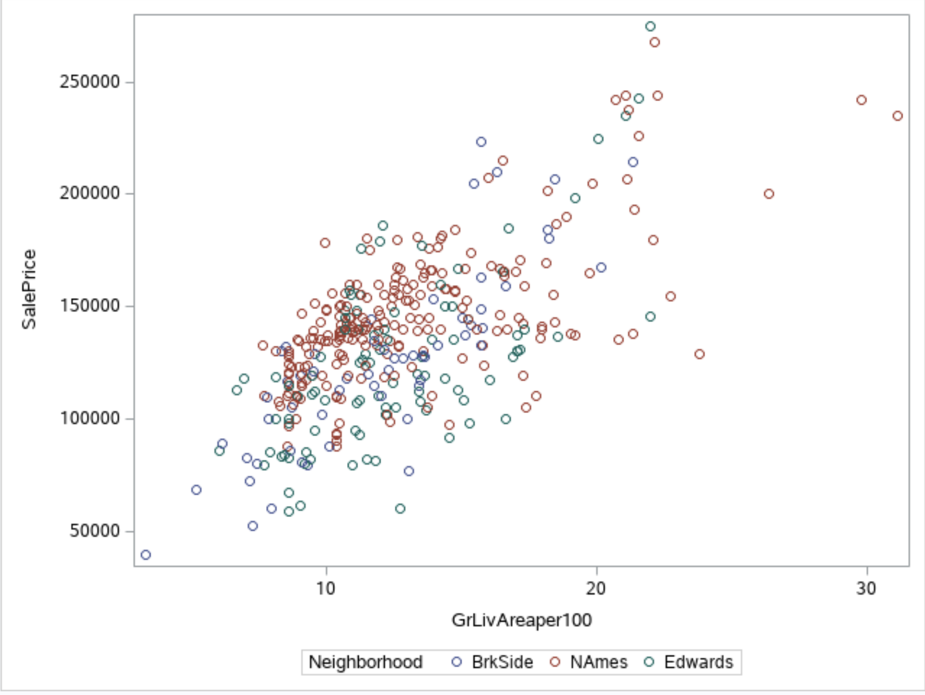

**PLOT 6**

**Create a Model for Sales price to GrLivArea per 100 sqft:**

proc glm data = logtrain3 plots=all;

class Neighborhood;

model SalePrice = GrLivAreaper100 | Neighborhood / cli clm clparm;

run;

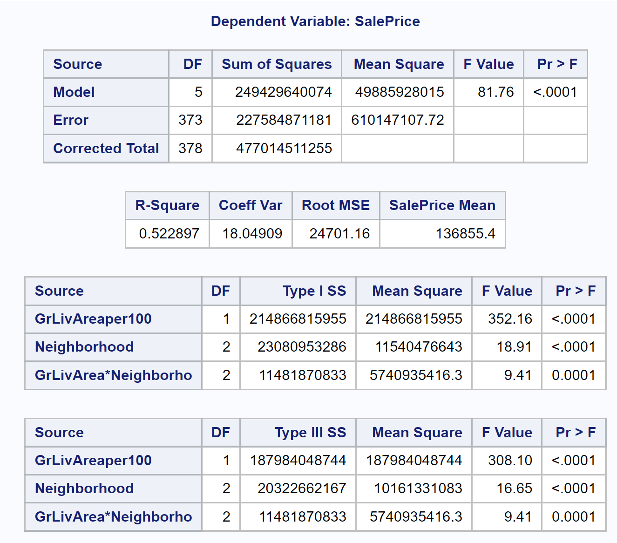

Filtering all homes greater than 40 sqft(100sqft);

data logtrain4;

set logtrain3;

where GrLivAreaper100 <= 40;

run;

Now re-Run the model again;

proc glm data = logtrain4 plots=all;

class Neighborhood;

model SalePrice = logGrLivAreaper100 | Neighborhood / cli clm clparm;

run;

Filtering all homes greater than $300,000;

data logtrain5;

set logtrain4;

where SalePrice <= 300000;

run;

Then, re-Run the model again;

proc glm data = logtrain5 plots=all;

class Neighborhood;

model SalePrice = GrLivAreaper100 | Neighborhood / cli clm clparm;

run;

**Last filtering out the homes that cost more than $300K and smaller than 40 100 sqft and run the model;**

proc glm data = logtrain6 plots=all;

class Neighborhood;

model SalePrice = GrLivAreaper100 | Neighborhood / cli clm clparm solution;

run;

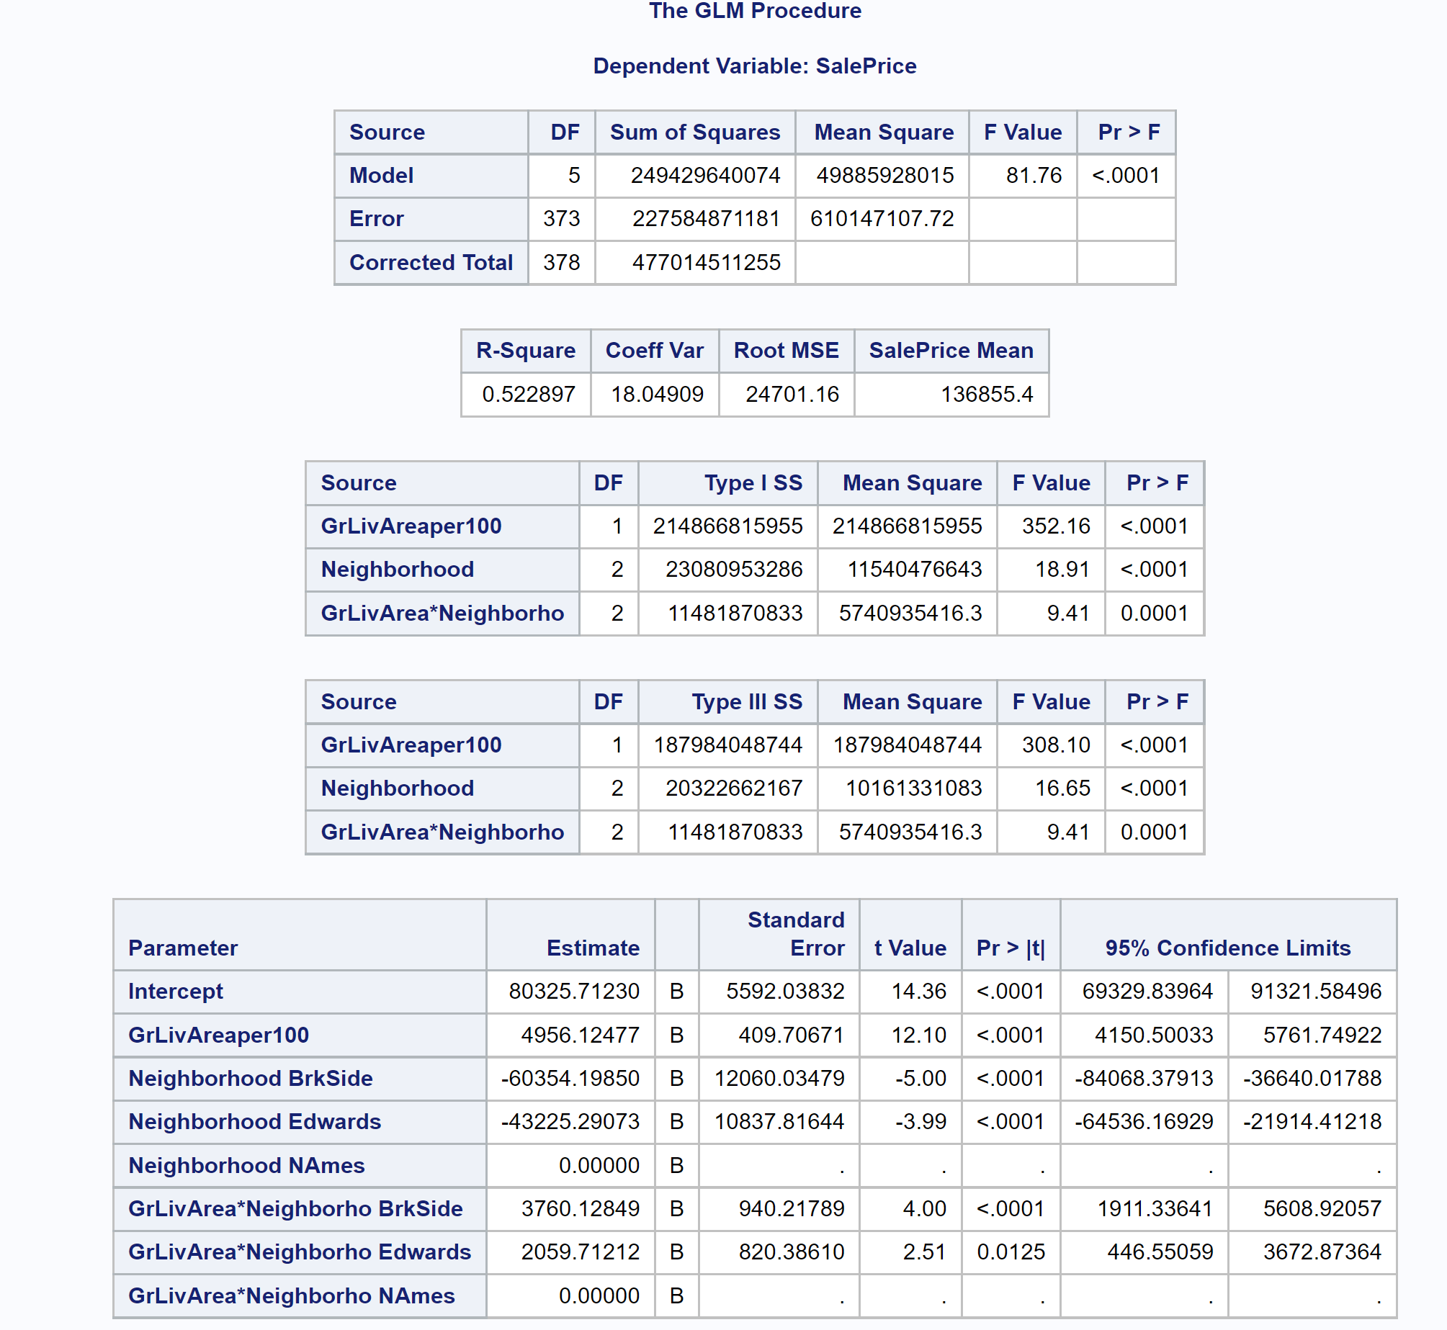

**Table 7**

**Now we compare Models through transformed data;**

1-Model with log transformed SalePrice  
proc glm data = logtrain4 plots=all;  
class Neighborhood;  
model logSalePrice = GrLivAreaper100 | Neighborhood / cli clm clparm;  
run;

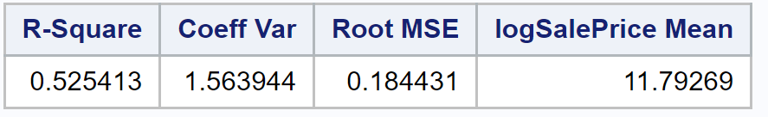

2-Model with log transformed GrLivAreaper100  
proc glm data = logtrain4 plots=all;  
class Neighborhood;  
model SalePrice = logGrLivAreaper100 | Neighborhood / cli clm clparm;  
run;

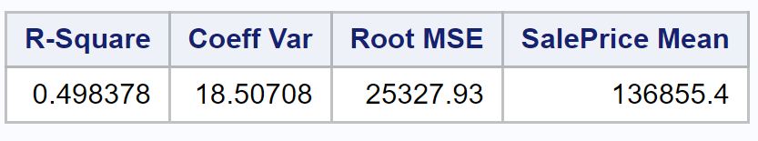

3-Model with log-log transformed SalePrice-GrLivAreaper100*  
proc glm data = logtrain4 plots=all;  
class Neighborhood;  
model logSalePrice = logGrLivAreaper100 | Neighborhood / cli clm clparm;  
run;

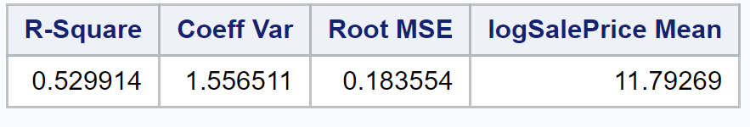

4-Model with log-log transformed SalePrice-GrLivAreaper100 on homes that are less than $300,000 and 40 100 sq. ft.  
proc glm data = logtrain6 plots=all;  
class Neighborhood;  
model logSalePrice = logGrLivAreaper100 | Neighborhood / cli clm clparm; run;

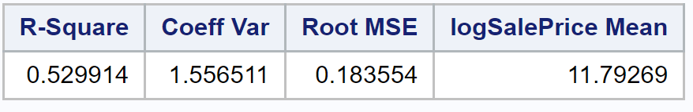

1-Model with log transformed SalePrice

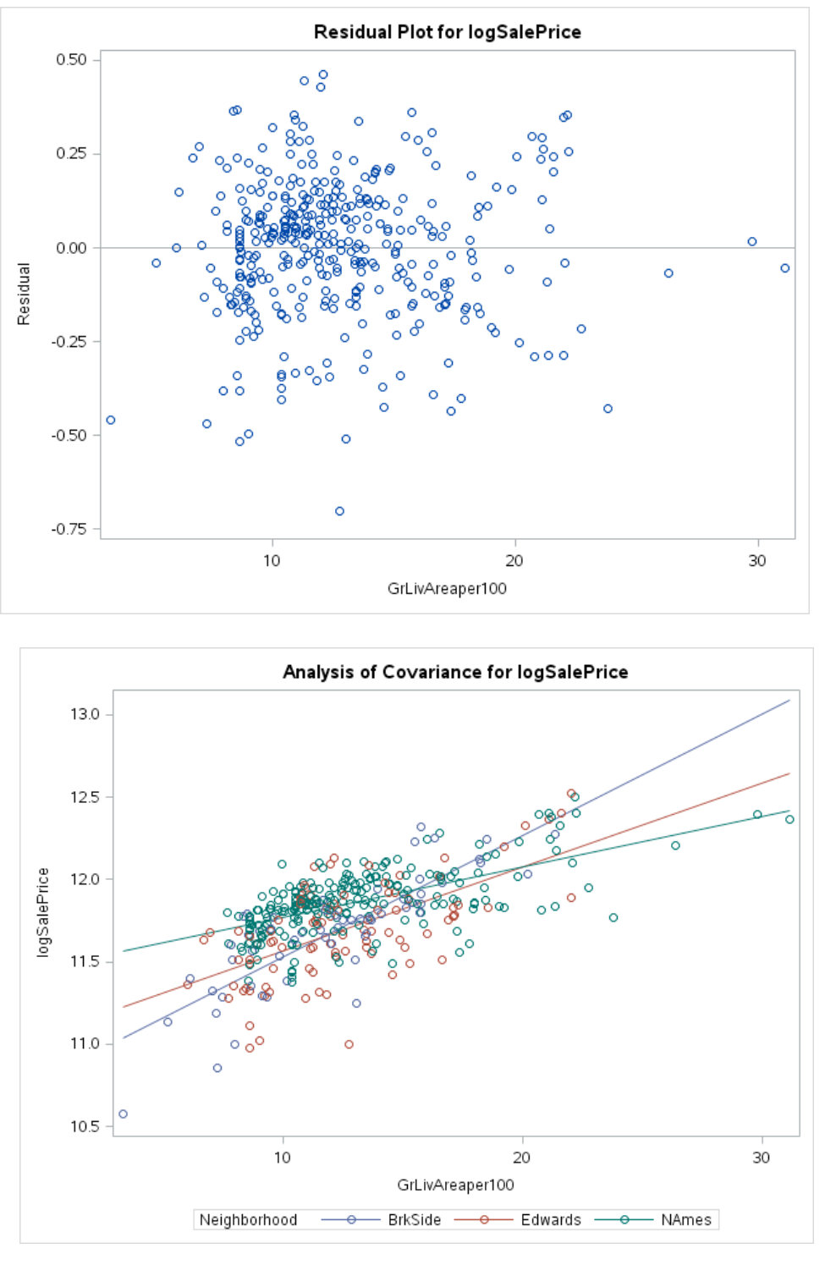

2-Model with log transformed GrLivAreaper100

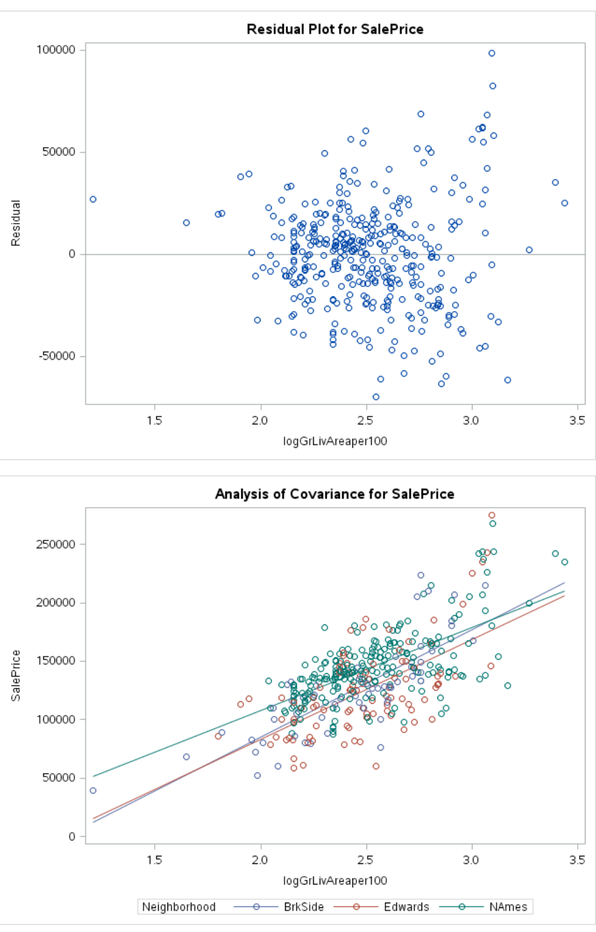

3-Model with log-log transformed SalePrice-GrLivAreaper100* & 4-Model with log-log transformed SalePrice-GrLivAreaper100 on homes that are less than $300,000 and 40 100 sq. ft.

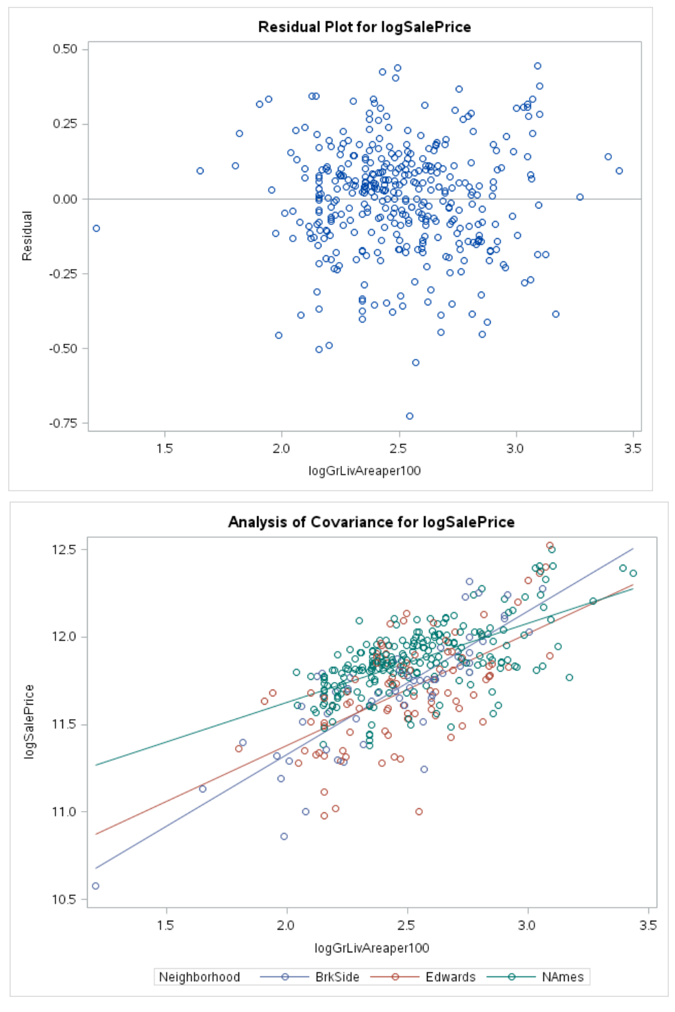

**SAS codes and plots for Analysis of Question 2:**

First, we preparing data and the using the Multiple Regression Model for SalePrice Prediction by selecting numerical variables as predictors. Then, we removing variables with NA's: LotFrontage MasVnrArea GarageYrBlt and also, removing variables with wrong name: 1stFlrSF 2ndFlrSF 3SsnPorch(IMPORT is the Train.csv dataset):

data trainAmes2;

set IMPORT;

keep Id MSSubClass LotArea OverallQual OverallCond YearBuilt YearRemodAdd BsmtFinSF1 BsmtFinSF2 BsmtUnfSF

LowQualFinSF GrLivArea BsmtFullBath BsmtHalfBath FullBath HalfBath BedroomAbvGr

KitchenAbvGr TotRmsAbvGrd

Fireplaces GarageCars GarageArea WoodDeckSF OpenPorchSF EnclosedPorch ScreenPorch PoolArea MiscVal MoSold

YrSold SalePrice;

run;

Then we have selected 31 numerical variables as predictors. Here we have removed variables with NA's (LotFrontage, MasVnrArea, GarageYrBlt) and variables with wrong name (1stFlrSF, 2ndFlrSF, 3SsnPorch).

We have 1460 observations and 31 variables.

proc print data=trainAmes2; run;

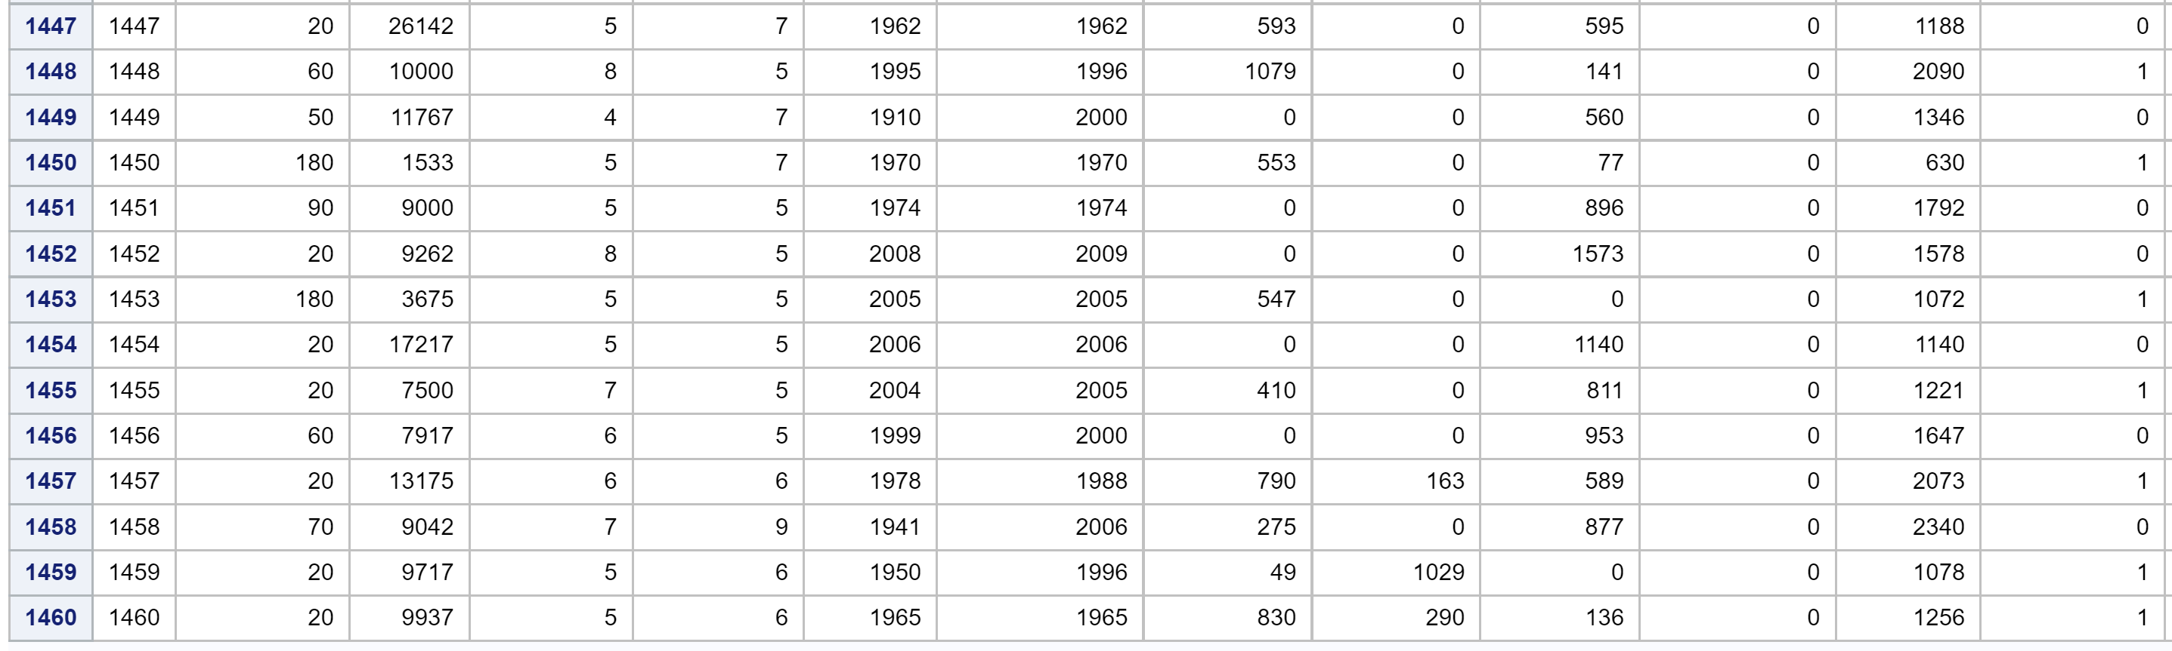

**Table 8**

Variable selections with Scatter plots:

PROC sgscatter data=trainAmes2;

matrix SalePrice MSSubClass LotArea OverallQual OverallCond YearBuilt YearRemodAdd;

run;

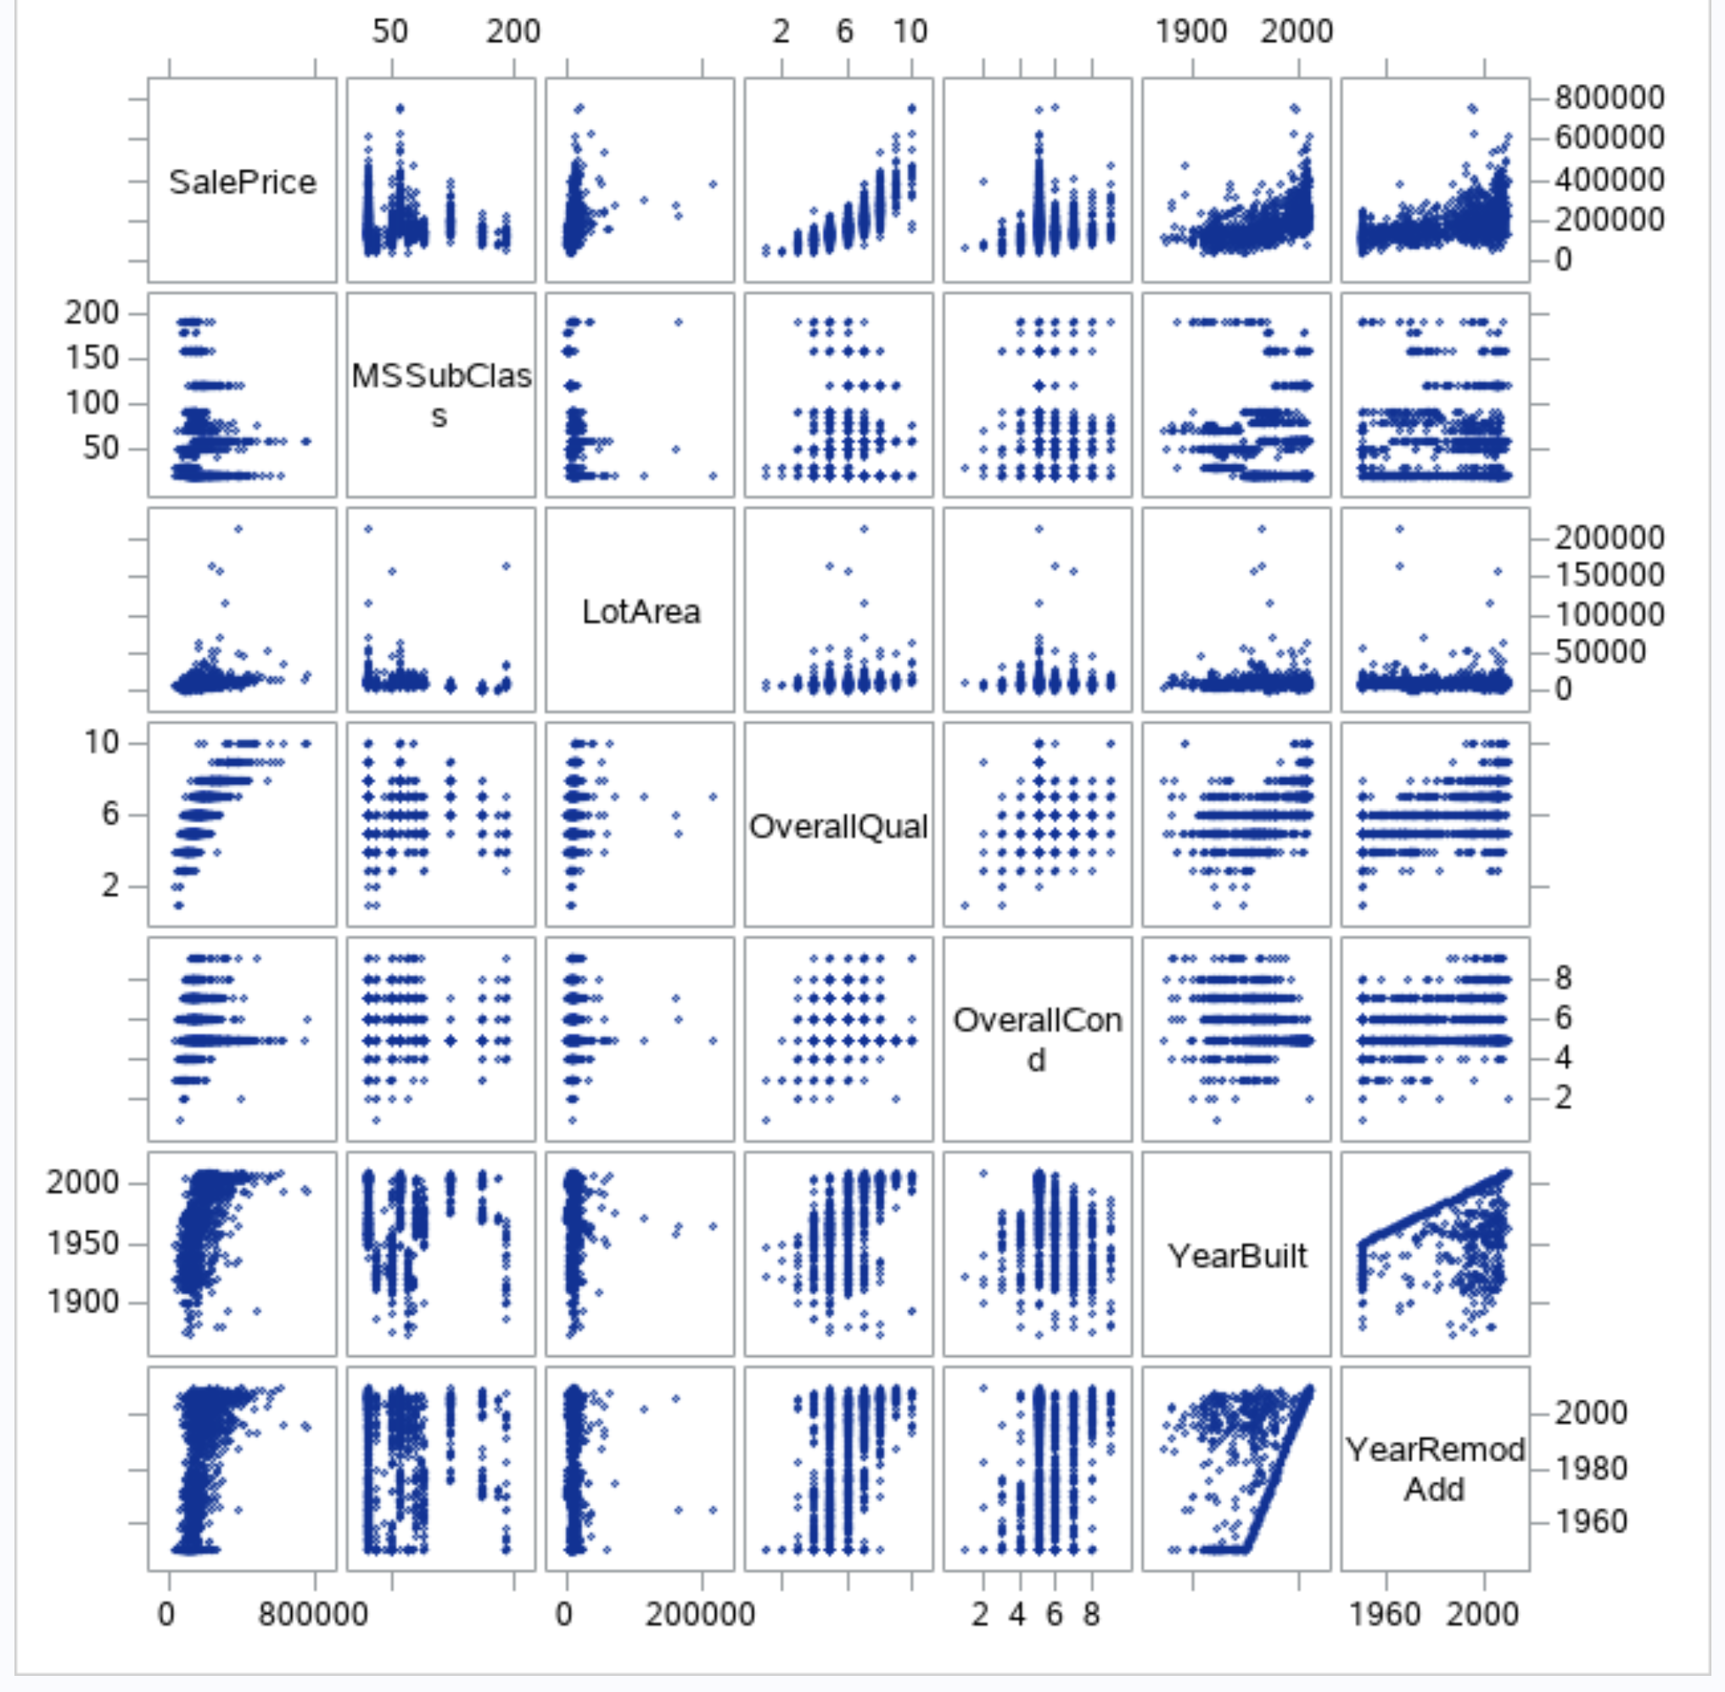

**PLOT 7**

Linear relationship: OverallQual, OverallCond, YearBuilt, YearRemodAdd

Nonlinear relationships are: NSSubClass, LotArea

Keeping 4 variables with linear relationship:

PROC sgscatter DATA=trainAmes2;

matrix SalePrice BsmtFinSF1 BsmtFinSF2 BsmtUnfSF LowQualFinSF GrLivArea; run;

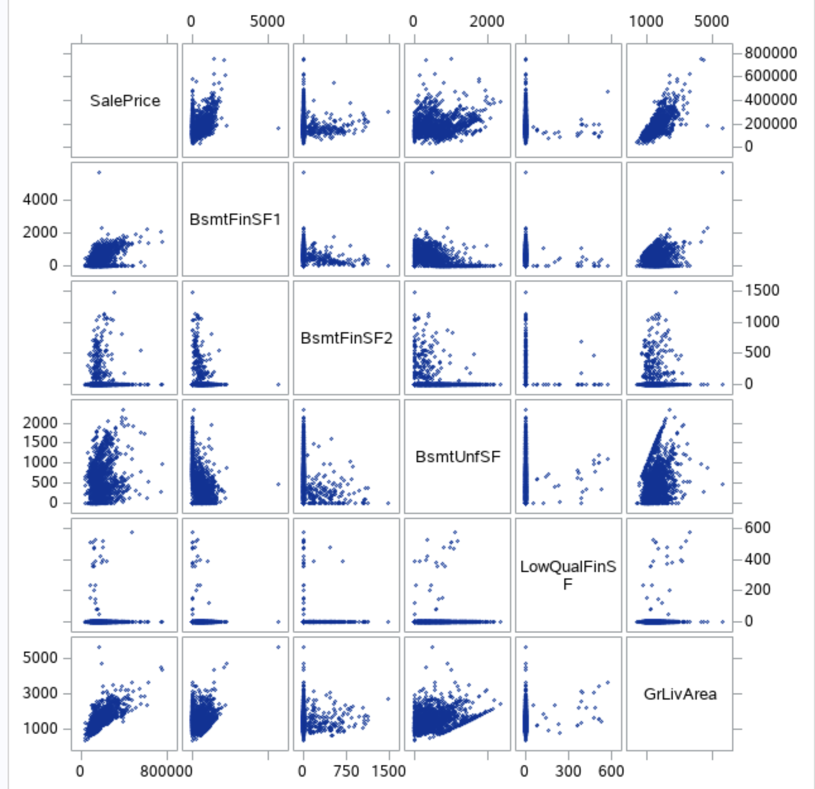

**PLOT 8**

Linear relationship: GrLivArea

Nonlinear relationship: BsmtFinSF1, BsmFinFS2, BsmUnfSF, LowQualFinSF

Keep 1 variable with linear relationship:

PROC sgscatter DATA=trainAmes2;

matrix SalePrice BsmtFullBath BsmtHalfBath FullBath HalfBath BedroomAbvGr KitchenAbvGr; run;

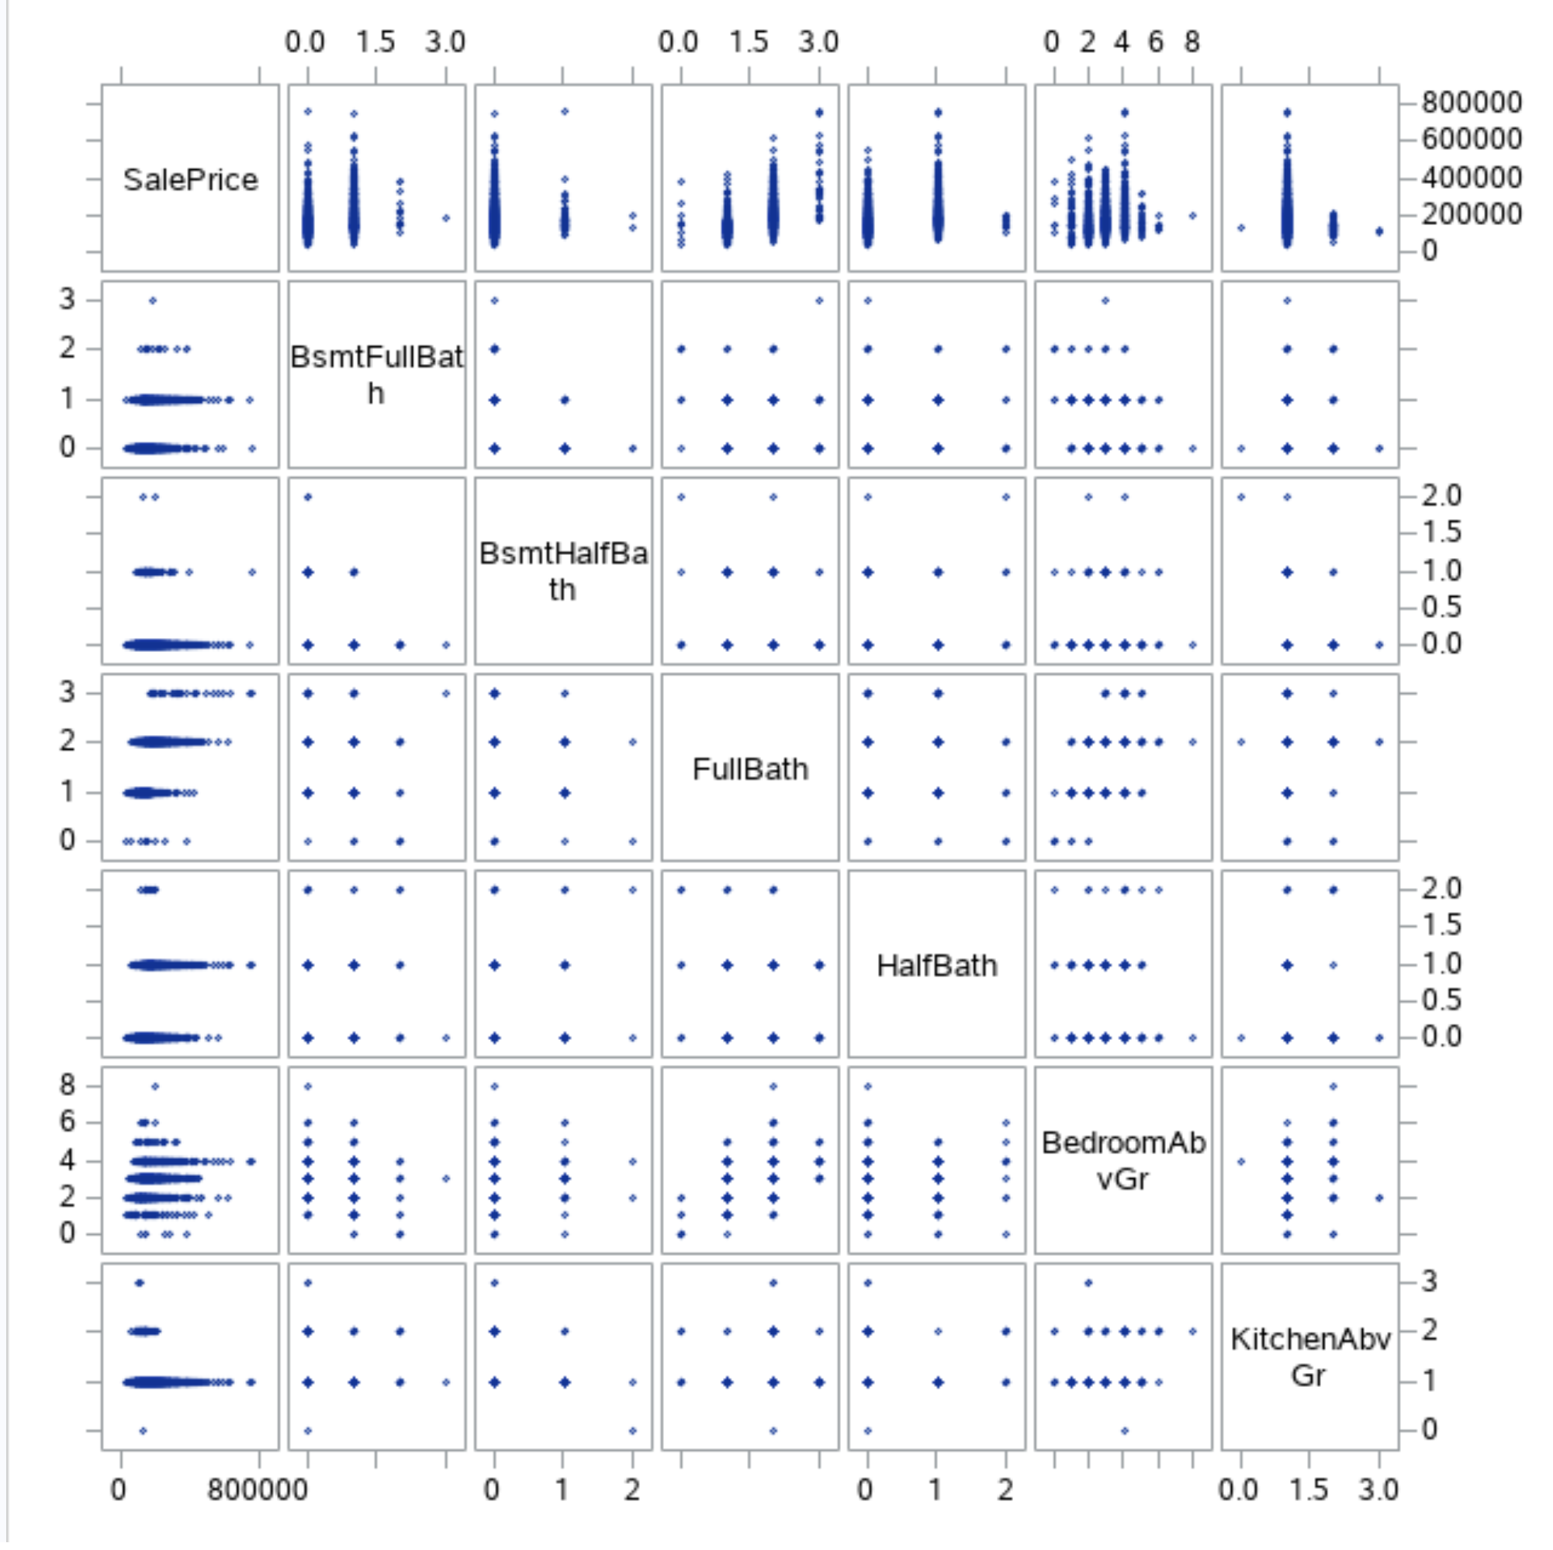

**PLOT 9**

Linear relationship: FullBath

Nonlinear relationship: BsmtFullBath, BsmtHalfBath, HalfBath, BedroomAbvGr, KitchenAbvGr

Keep 1 variable with linear relationship

PROC sgscatter DATA=trainAmes2;

matrix SalePrice TotRmsAbvGrd Fireplaces GarageCars GarageArea WoodDeckSF; run;

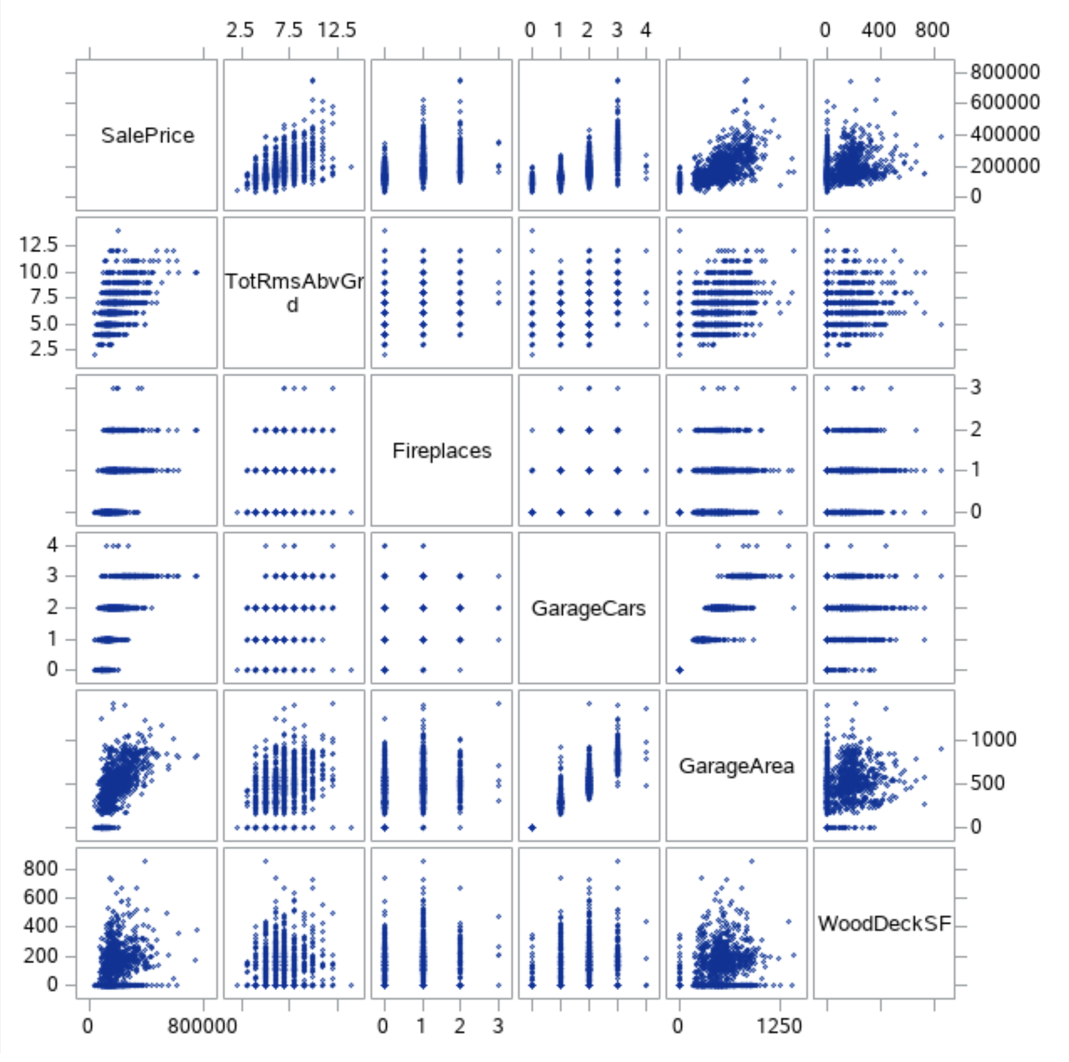

**PLOT 10**

Linear relationship: TotRmsAbvGrd, Fireplaces, GarageCars, GarageArea, WoodDeckSF

Nonlinear relationship: None

Keep 5 variable with linear relationship

PROC sgscatter DATA=trainAmes2;

matrix SalePrice OpenPorchSF EnclosedPorch ScreenPorch PoolArea MiscVal MoSold YrSold; run;

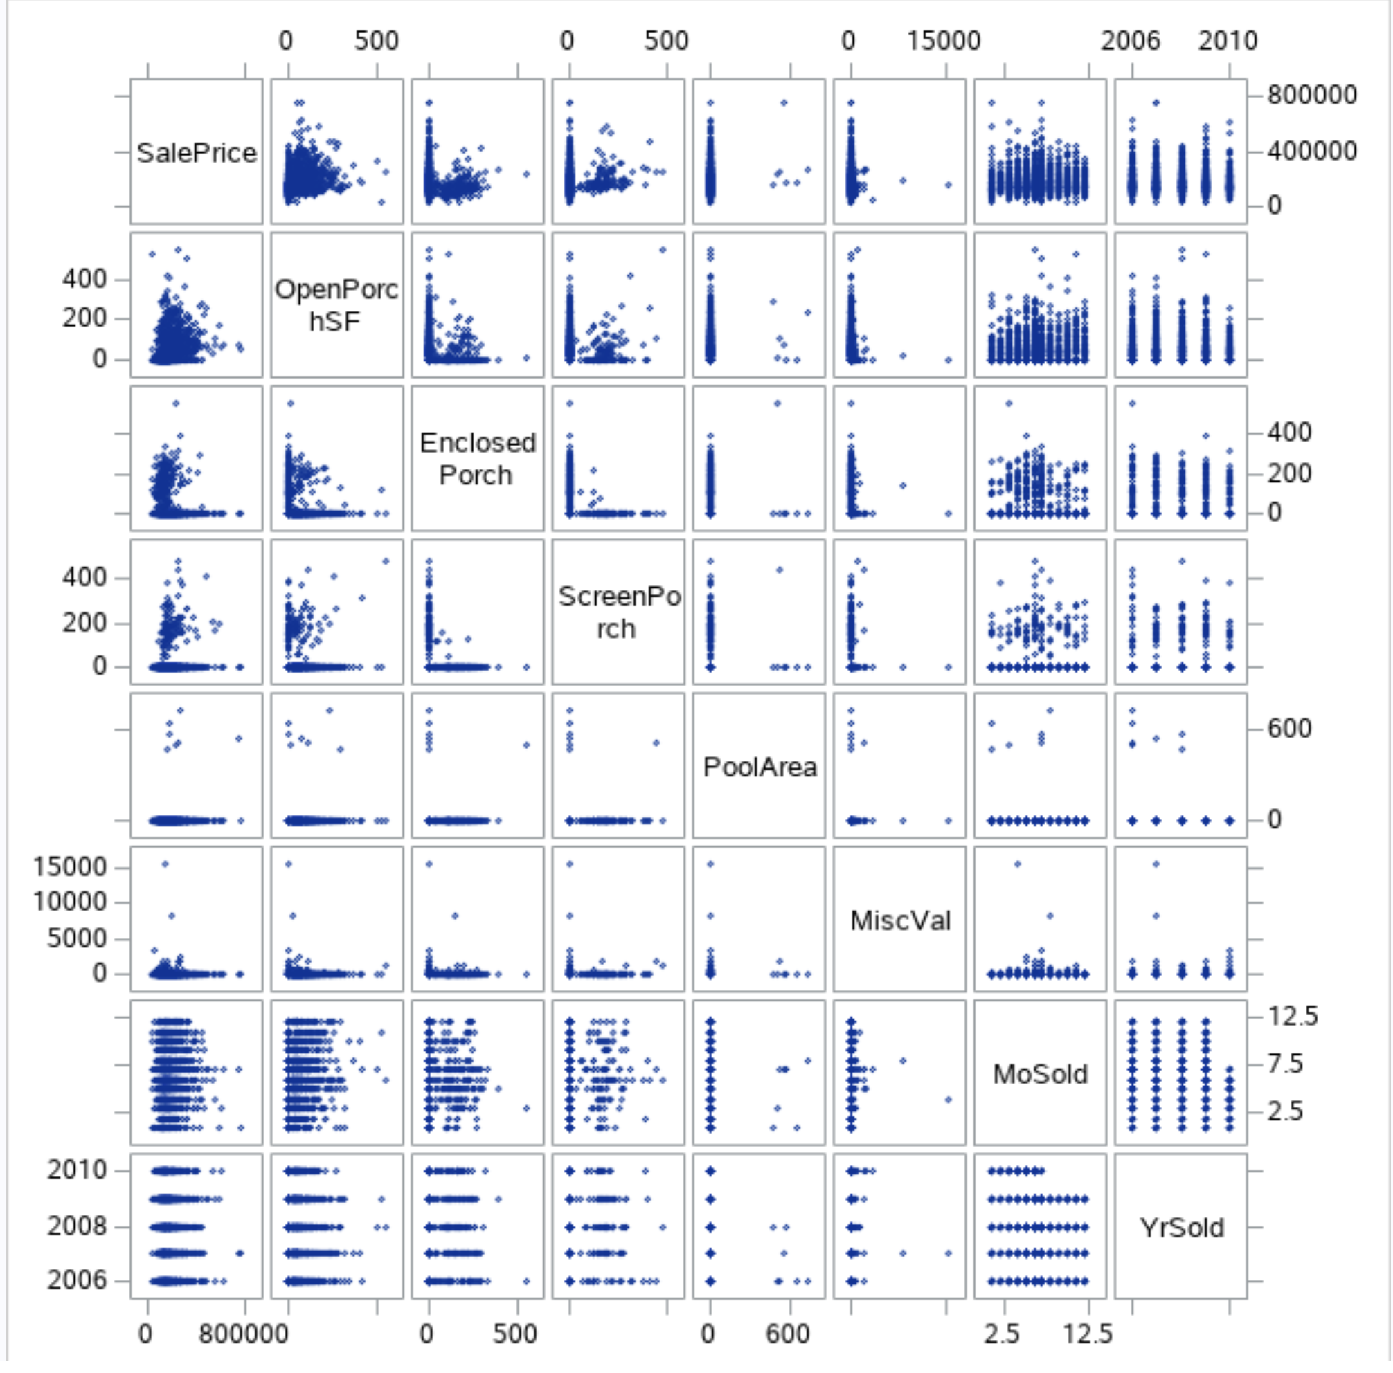

**PLOT 11**

Linear relationship: OpenPorchSF

Nonlinear relationship: EnclosedPorch, ScreenPorch, PoolArea, MiscVal, MoSold, YrSold

Keep 1 variable with linear relationship. There are 12 numerical variables are selected as candidate predictors through checking scatter plots which are as follow: OverallQual, OverallCond, YearBuilt, YearRemodAdd, GrLivArea, FullBath, TotRmsAbvGrd, Fireplaces, GarageCars, GarageArea, WoodDeckSF, OpenPorchSF.

Also, there is 13 categorical variables that we selected as candidate predictors base on SME's judgement:

Utilities, LotConfig, Neighborhood, ExterQual, BsmtQual, HeatingQC, KitchenQual,

FireplaceQu, GarageQual, PoolQC, Fence, SaleType, SaleCondition .

Removing the outliers:

data trainAmes2NoOutlier; set trainAmes2;

where Id ~= 643 AND Id ~= 725 AND Id ~= 1299 AND Id ~= 524; logSalePrice = log(SalePrice);

logOverallQual = log(OverallQual); run;

proc print data=trainAmes2NoOutlier; run;

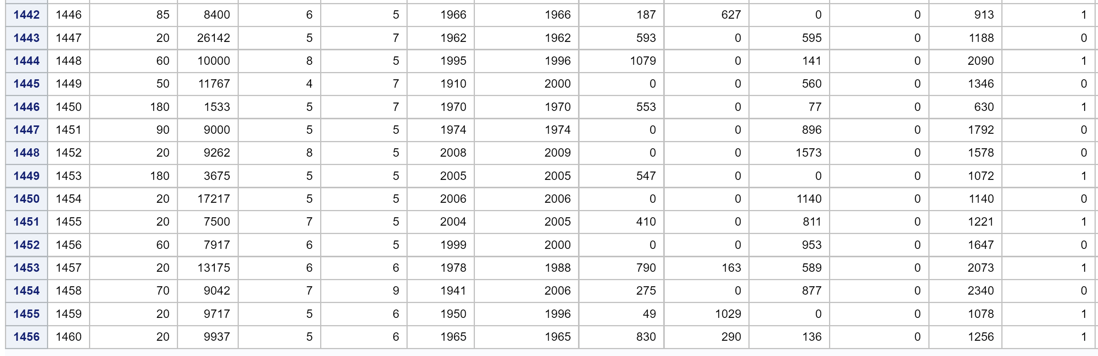

**Table 9**

Our cleaned new dataset has 1456 observations.

**Forward Method:**

Build model 1 with 12 numerical predictors:

proc reg data=trainames2Nooutlier;

model SalePrice = OverallQual OverallCond YearBuilt YearRemodAdd GrLivArea FullBath TotRmsAbvGrd

Fireplaces GarageCars GarageArea WoodDeckSF OpenPorchSF / selection=forward slentry=0.1 slstay=0.1 adjrsq; run;

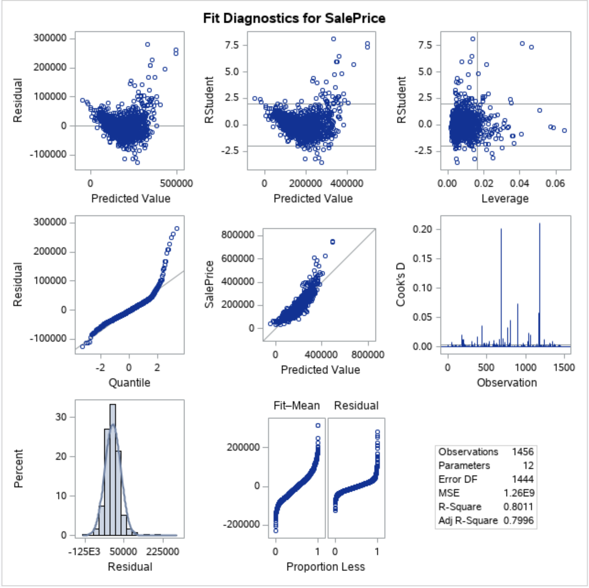

**PLOT 12**

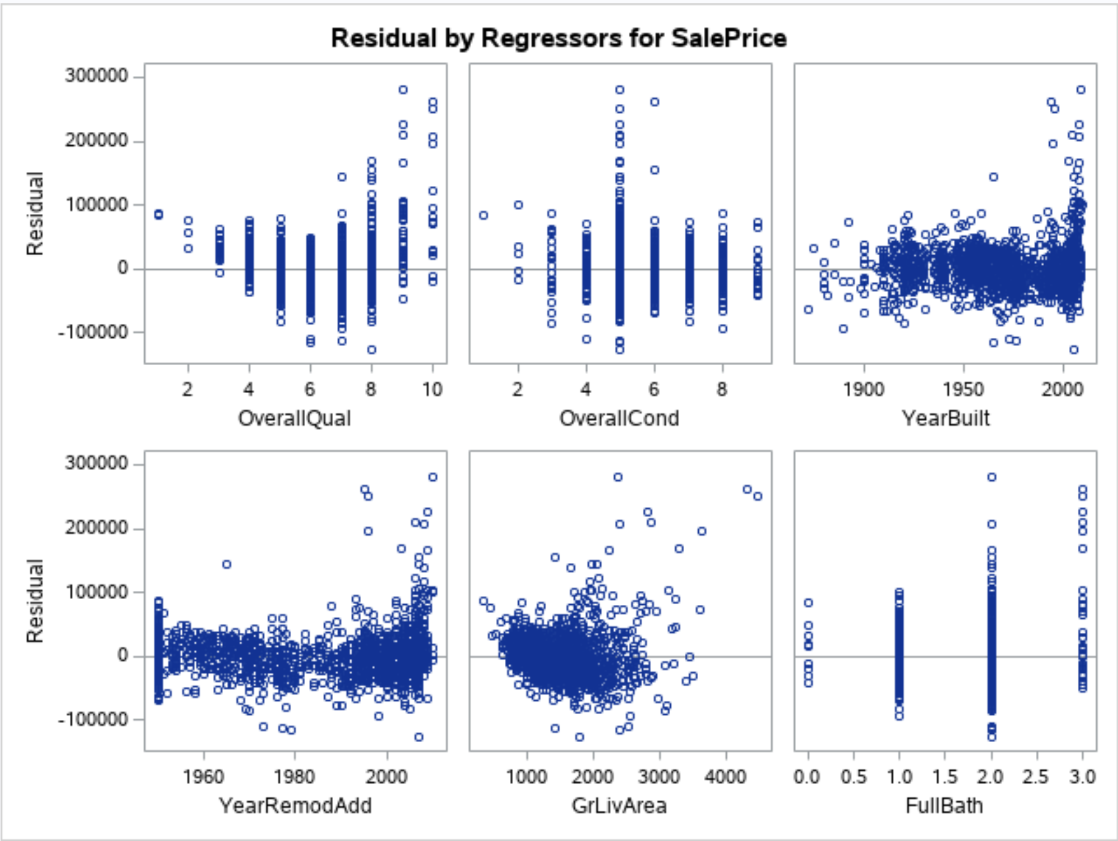

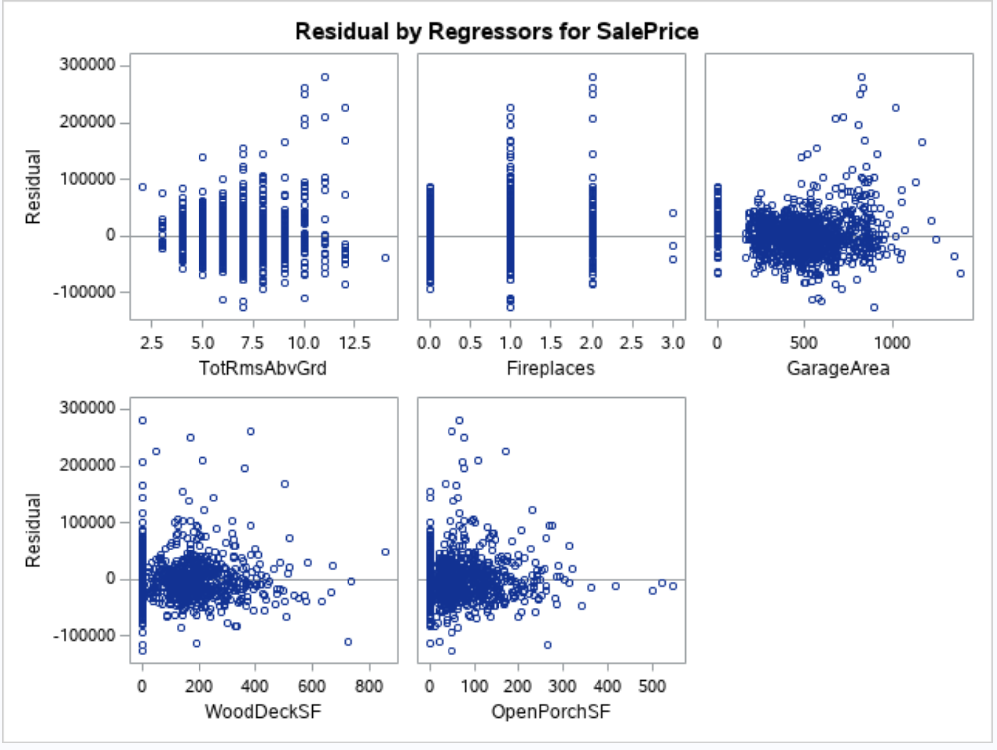

**PLOT 13**

The top 4 variables with the highest Partial R2 will be selected in the model.

Build model 2 with 4 numerical predictors with the highest partial R-square:

proc reg data=trainames2Nooutlier;

model SalePrice = OverallQual GrLivArea GarageArea YearBuilt / selection=forward slentry=0.1 slstay=0.1 adjrsq; run;

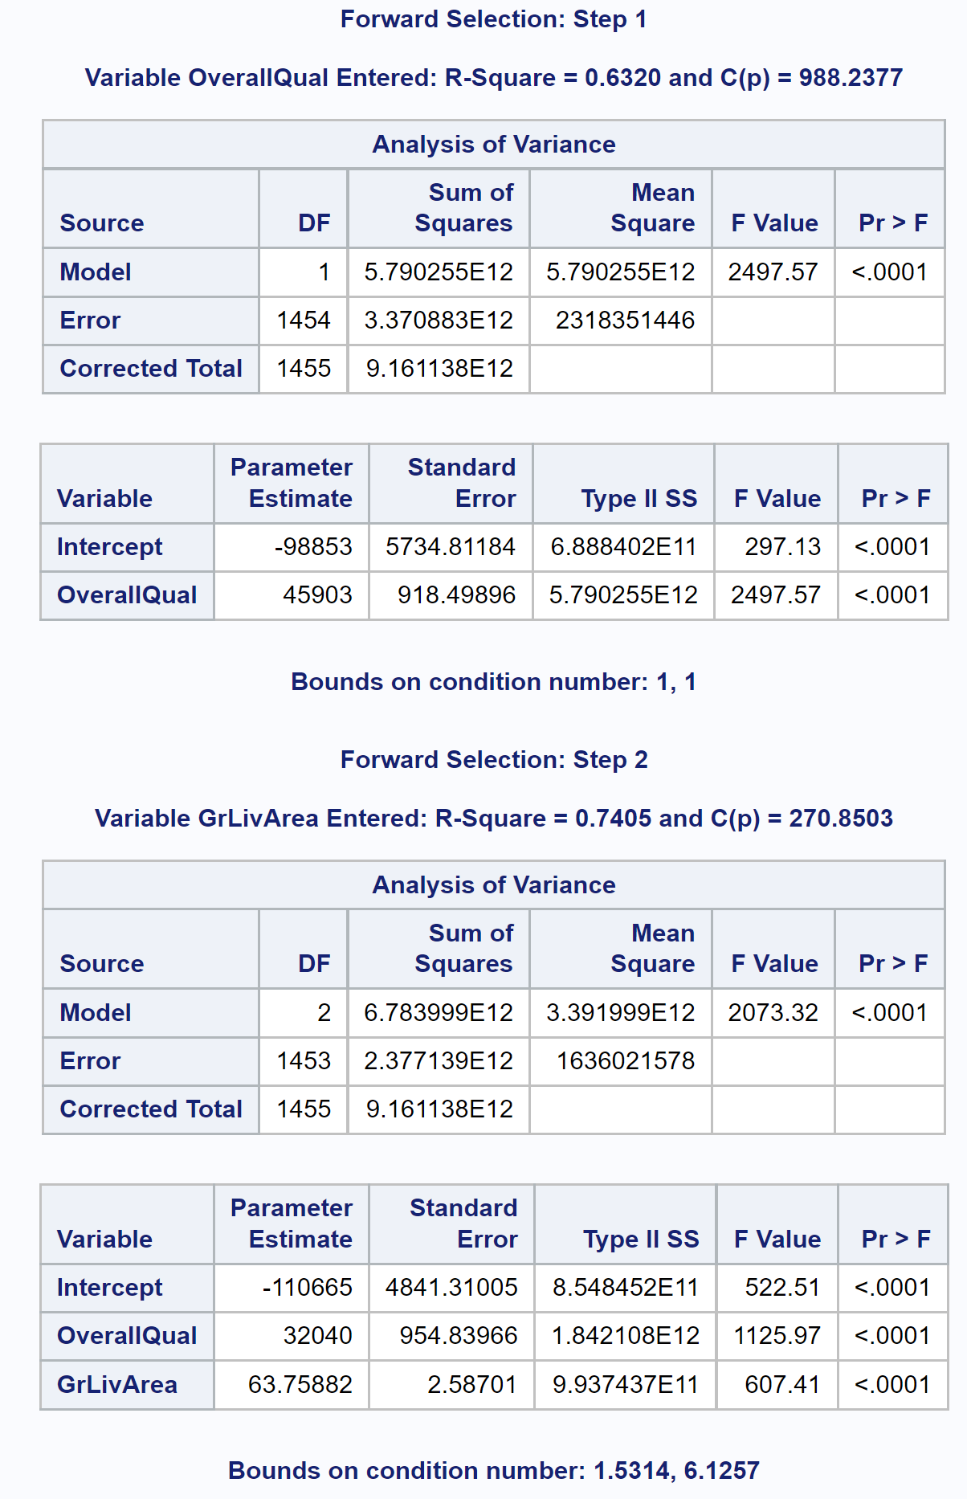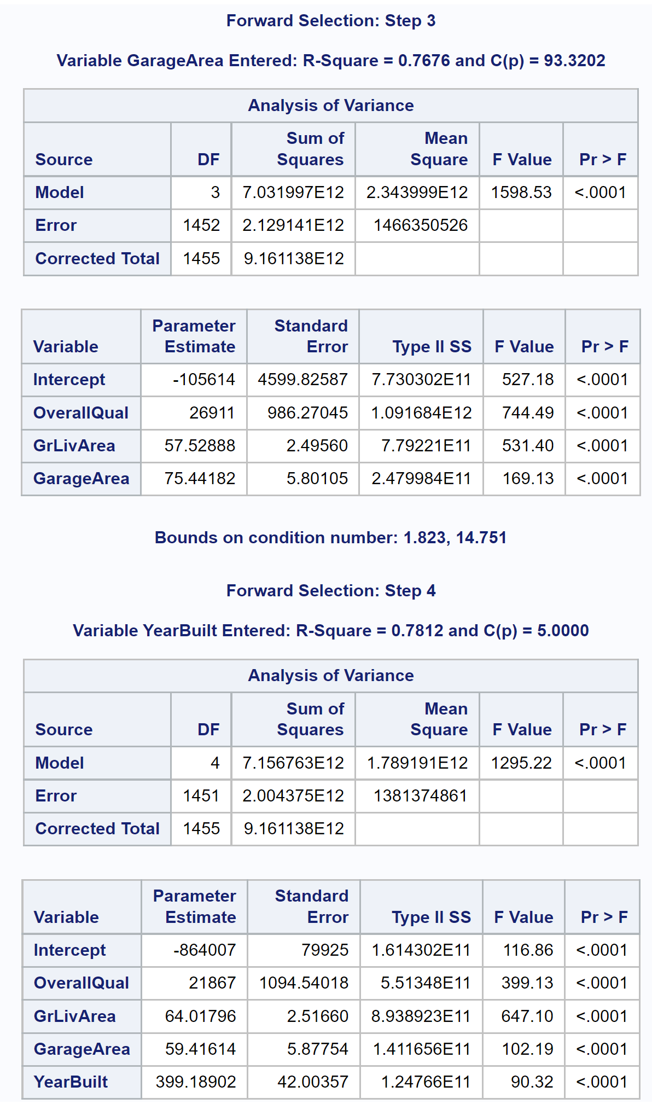

**Table 10**

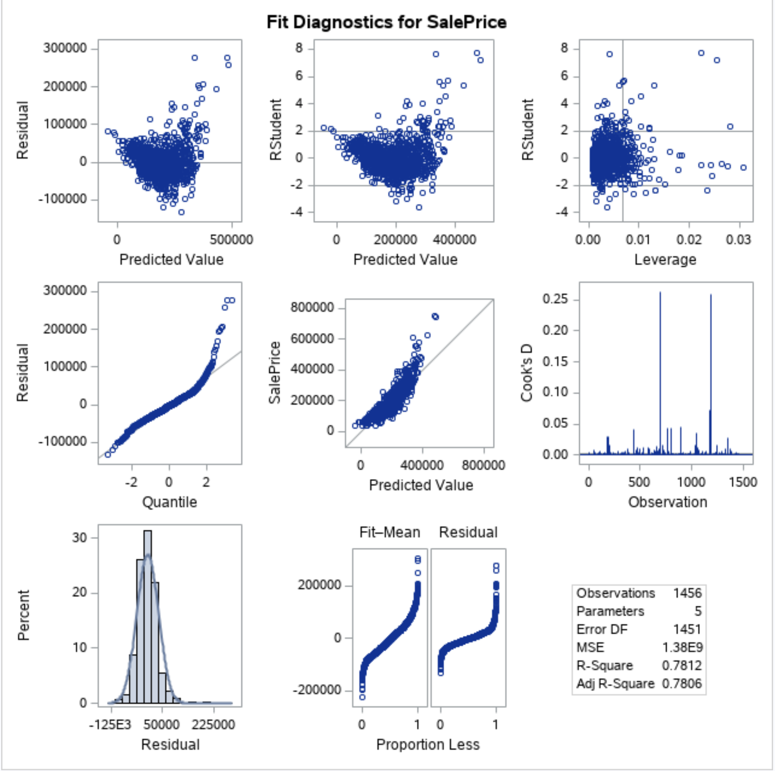

**PLOT 14**

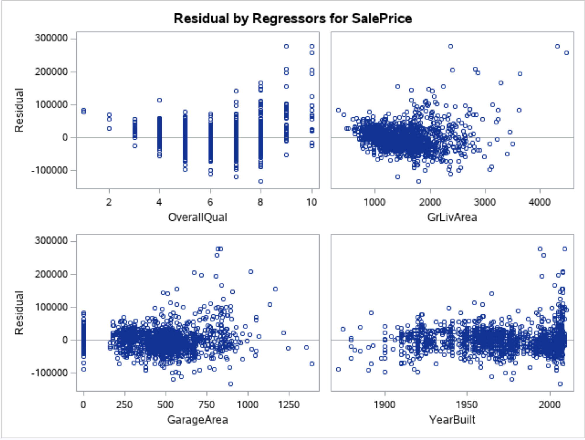

**PLOT 15**

Looks like there is curve relationship between SalePrice and OverallQual

Build model 3 with log transformation:

proc reg data=trainames2Nooutlier;

model logSalePrice = logOverallQual GrLivArea GarageArea YearBuilt / selection=forward slentry=0.1 slstay=0.1 adjrsq; run;

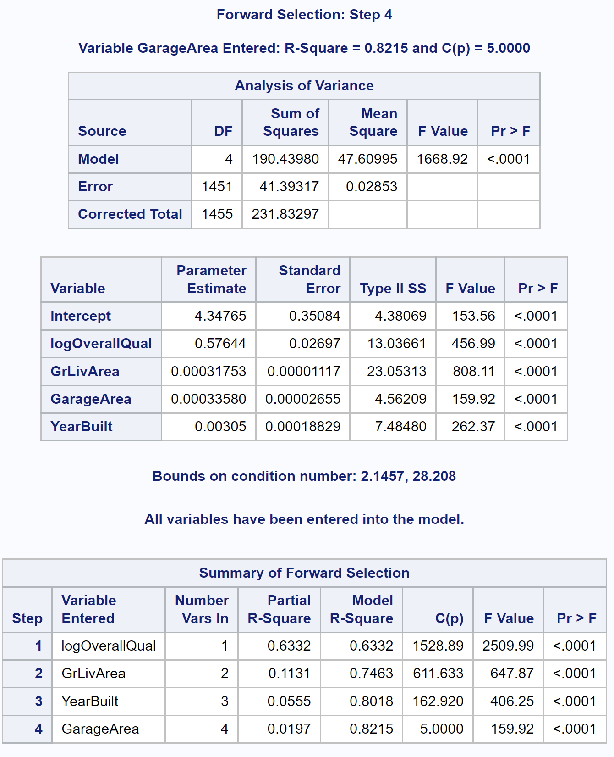

**Table 11**

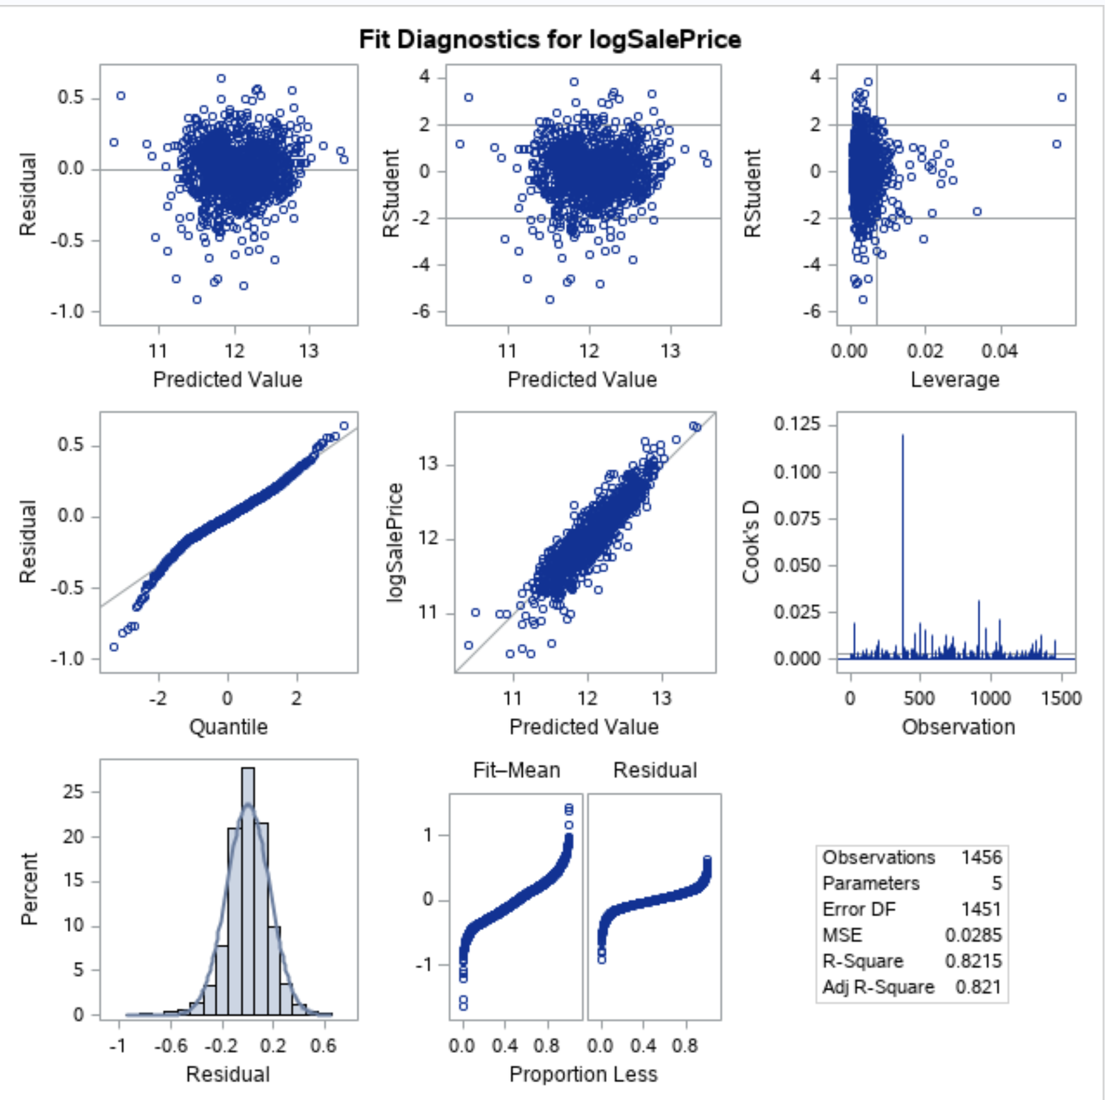 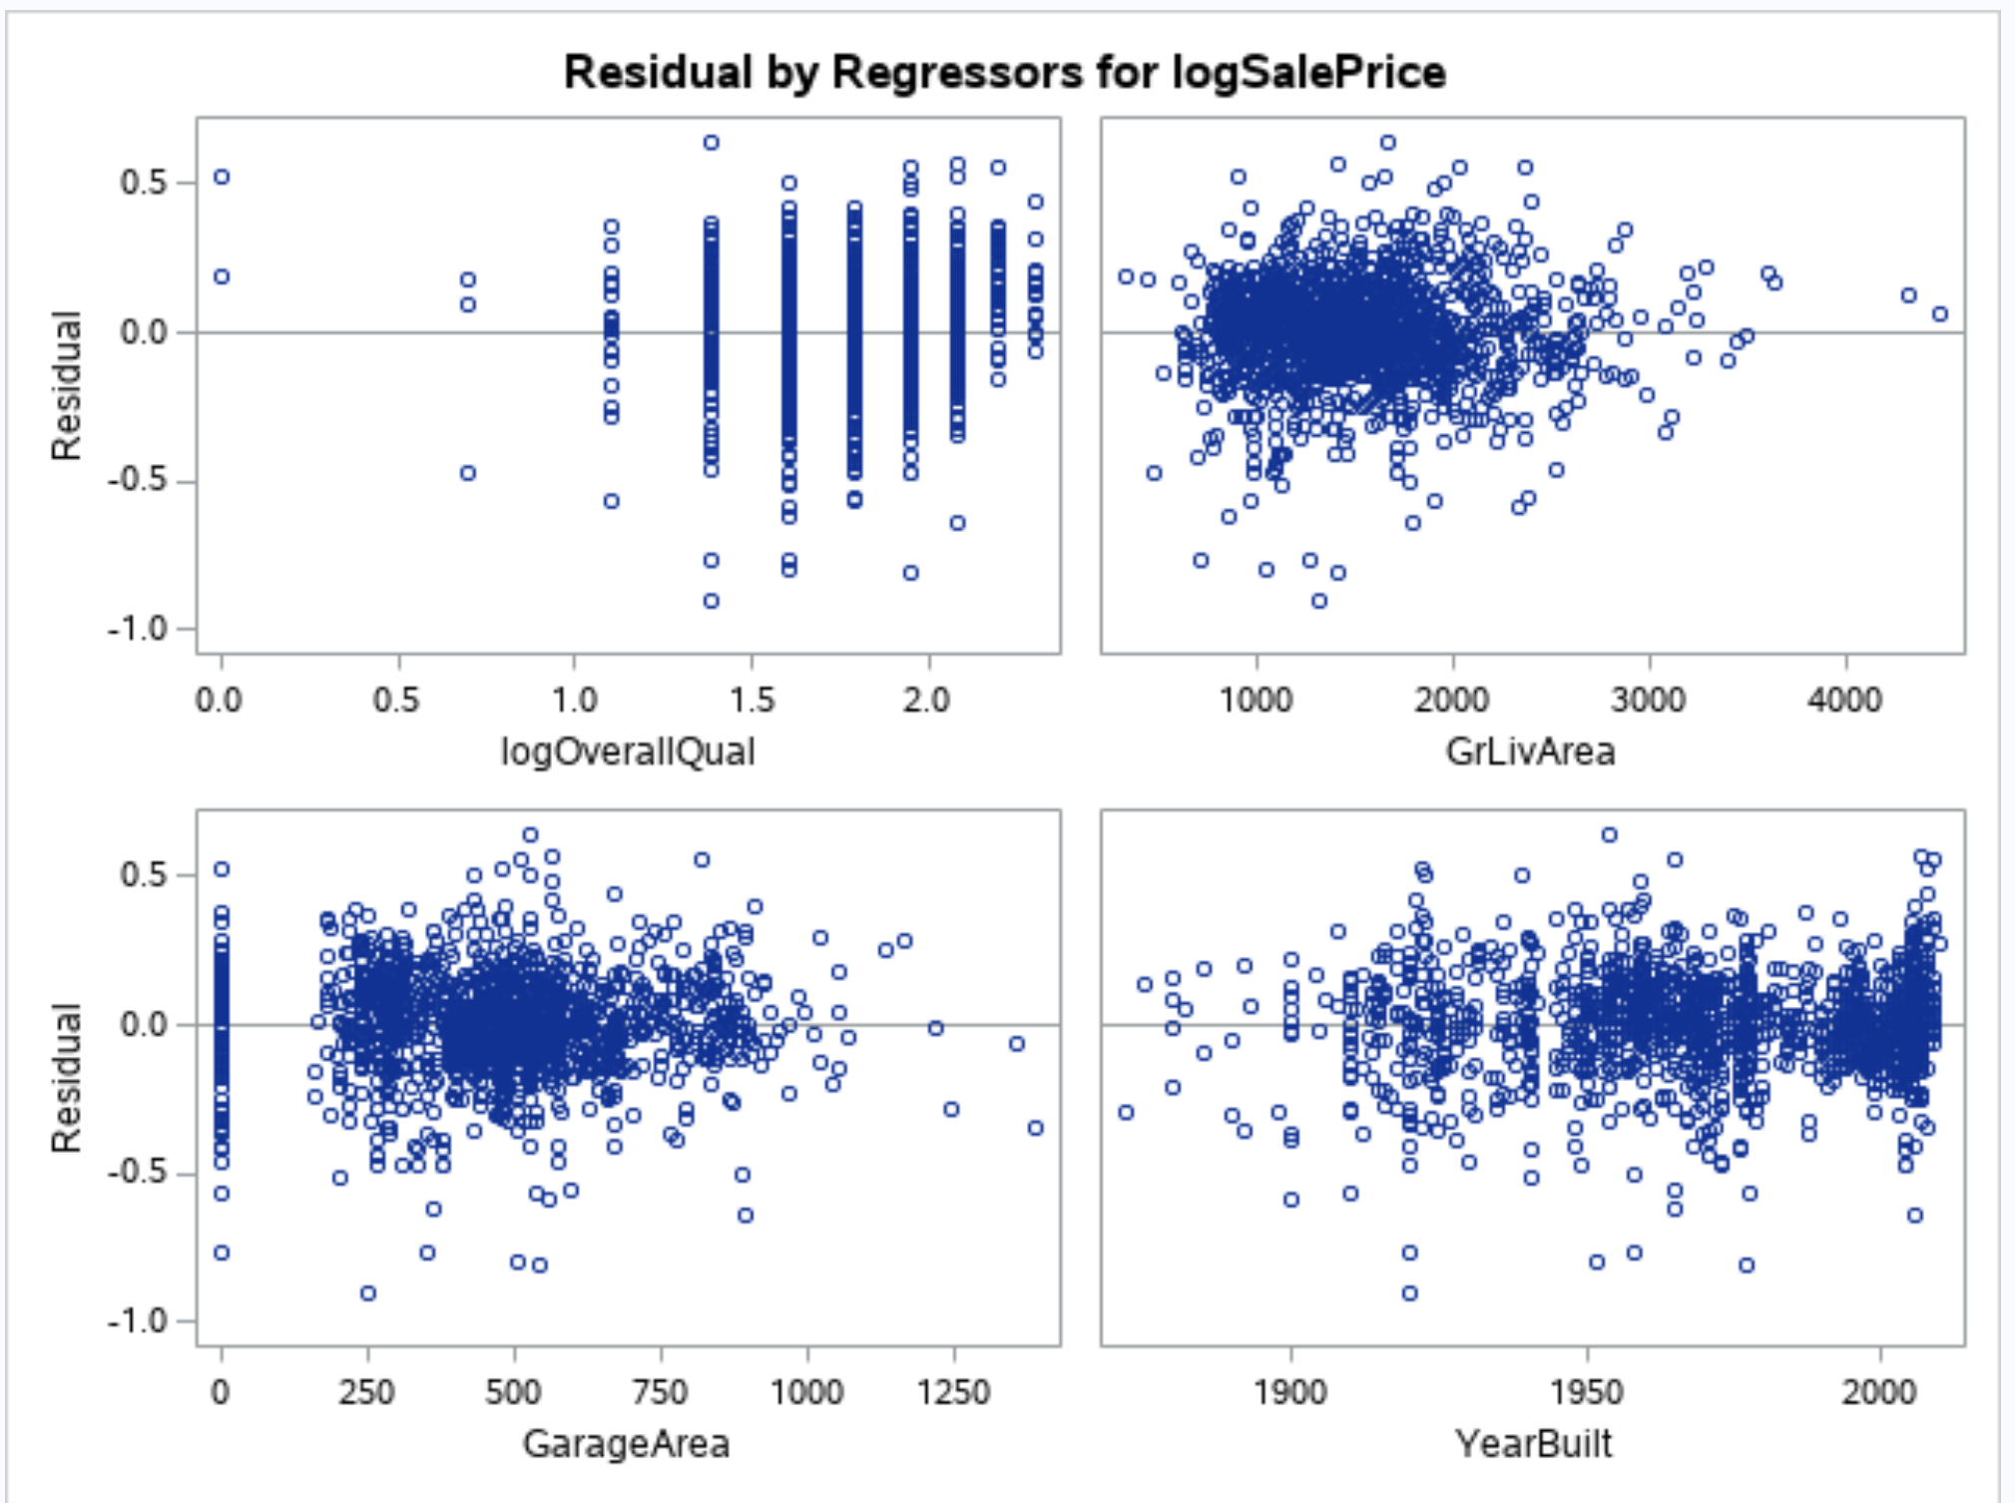

**PLOT 16**

Log transformed variables of OverallQuall and SalePrice are used in model.

Adj R-Square = 0.8215 after 4 steps

Residual scatter plots look much better, straight line in QQ plot.

**Backward Method:**

Build model 4 with 12 numerical predictors.

proc reg data=trainames2Nooutlier;

model SalePrice = OverallQual OverallCond YearBuilt YearRemodAdd GrLivArea FullBath TotRmsAbvGrd Fireplaces GarageCars GarageArea WoodDeckSF OpenPorchSF / selection=backward slentry=0.1 slstay=0.05 adjrsq aic bic cp partialr2 press sp vif;

run;

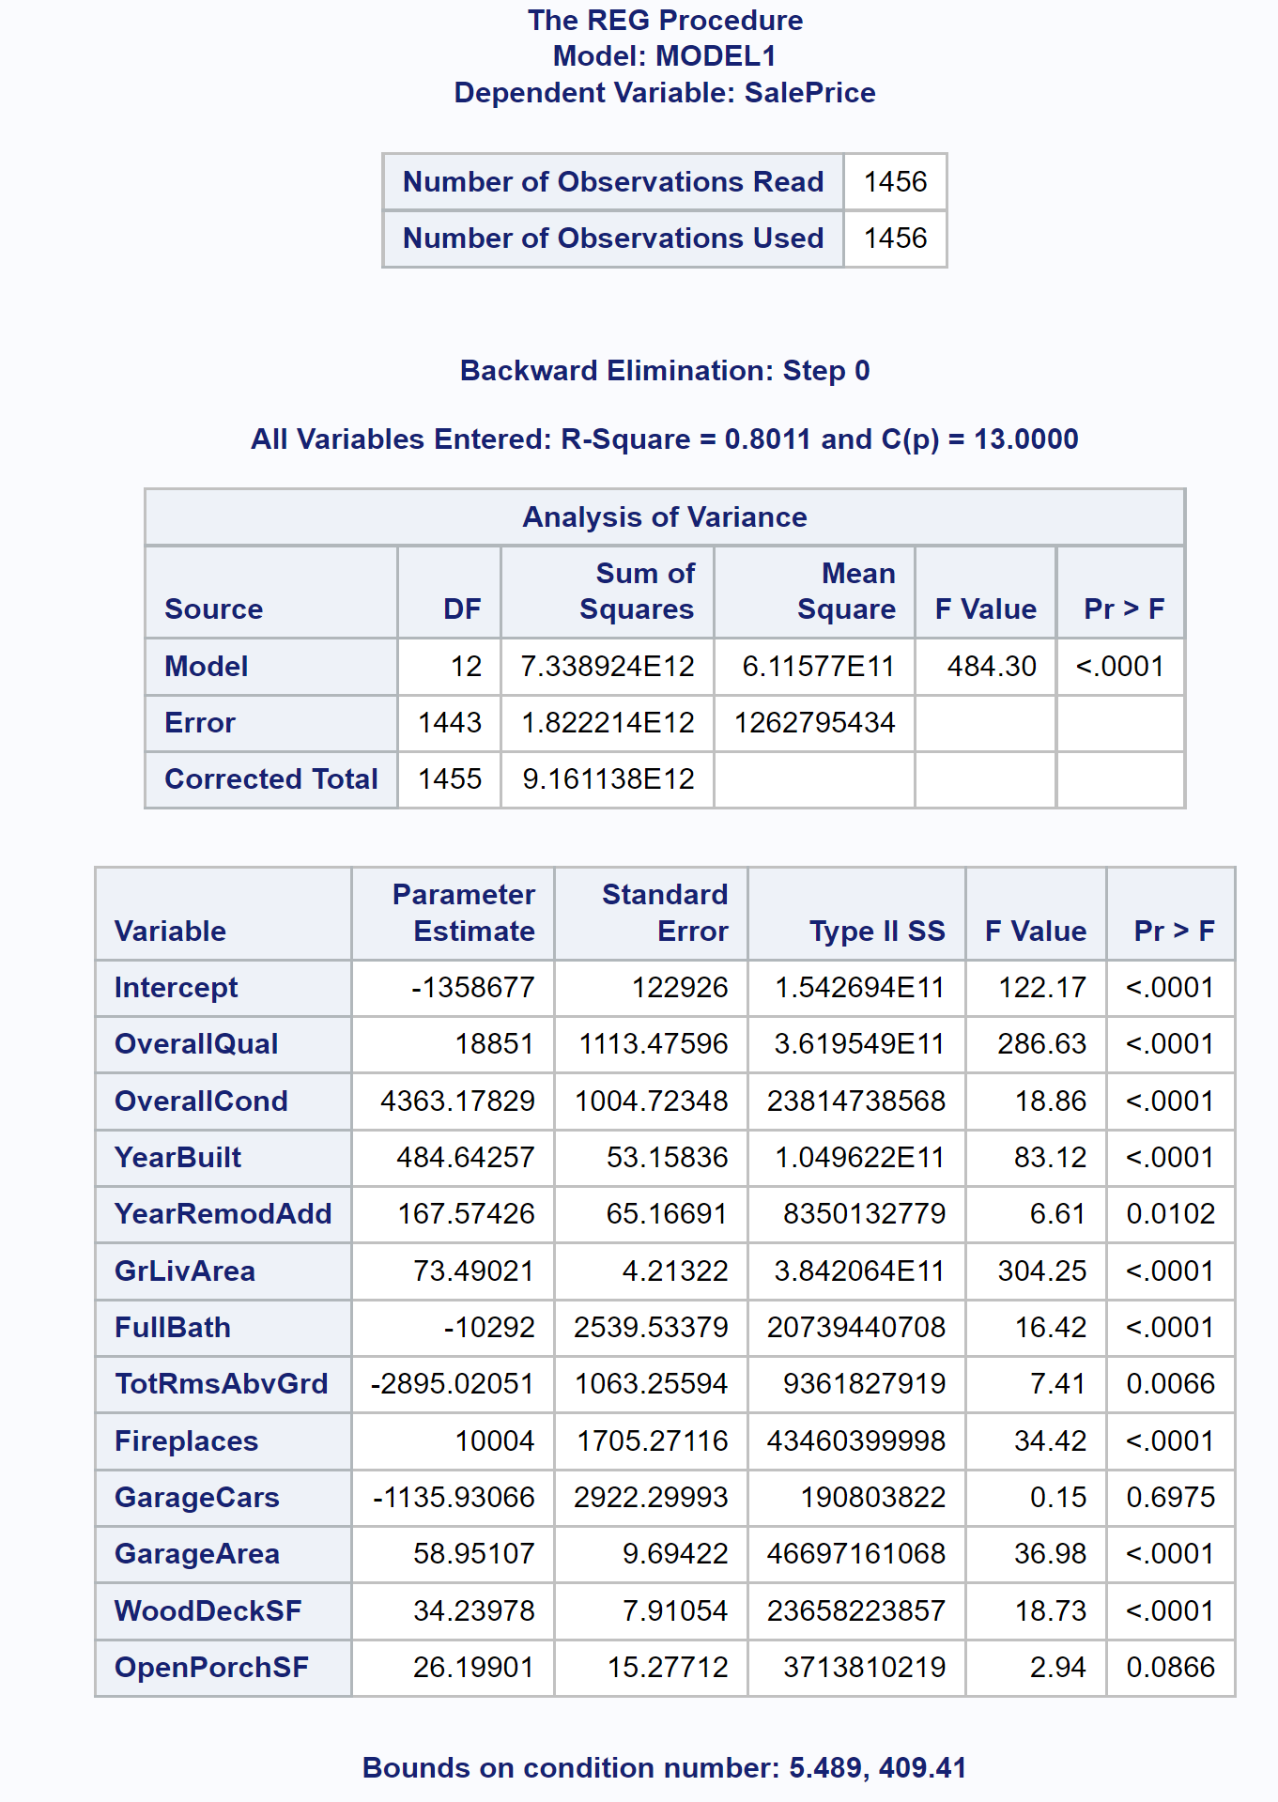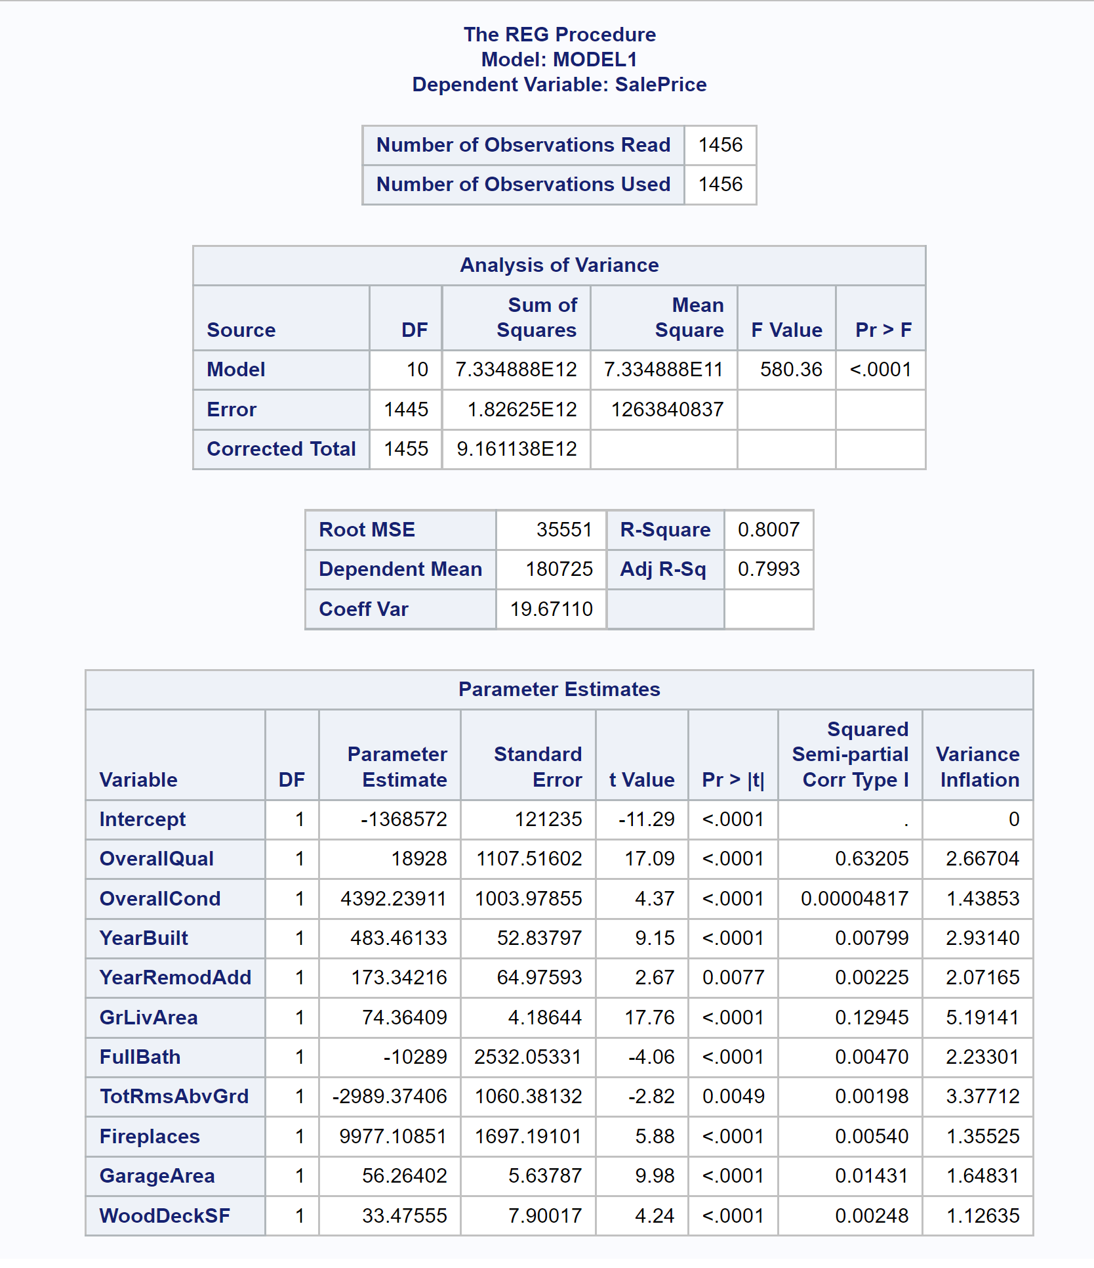

**Table 12**

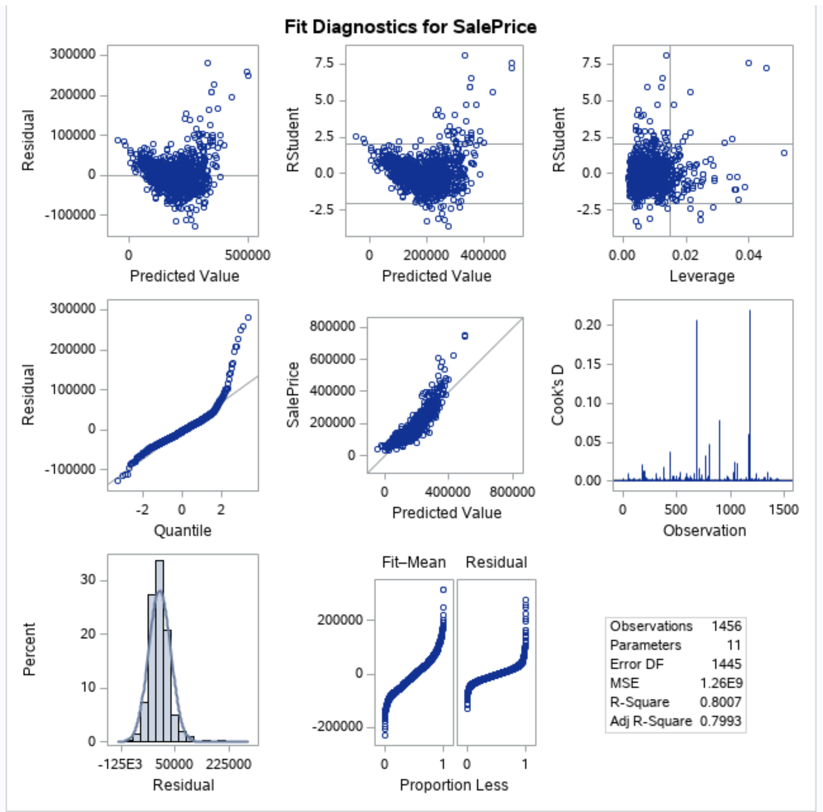

**PLOT 17**

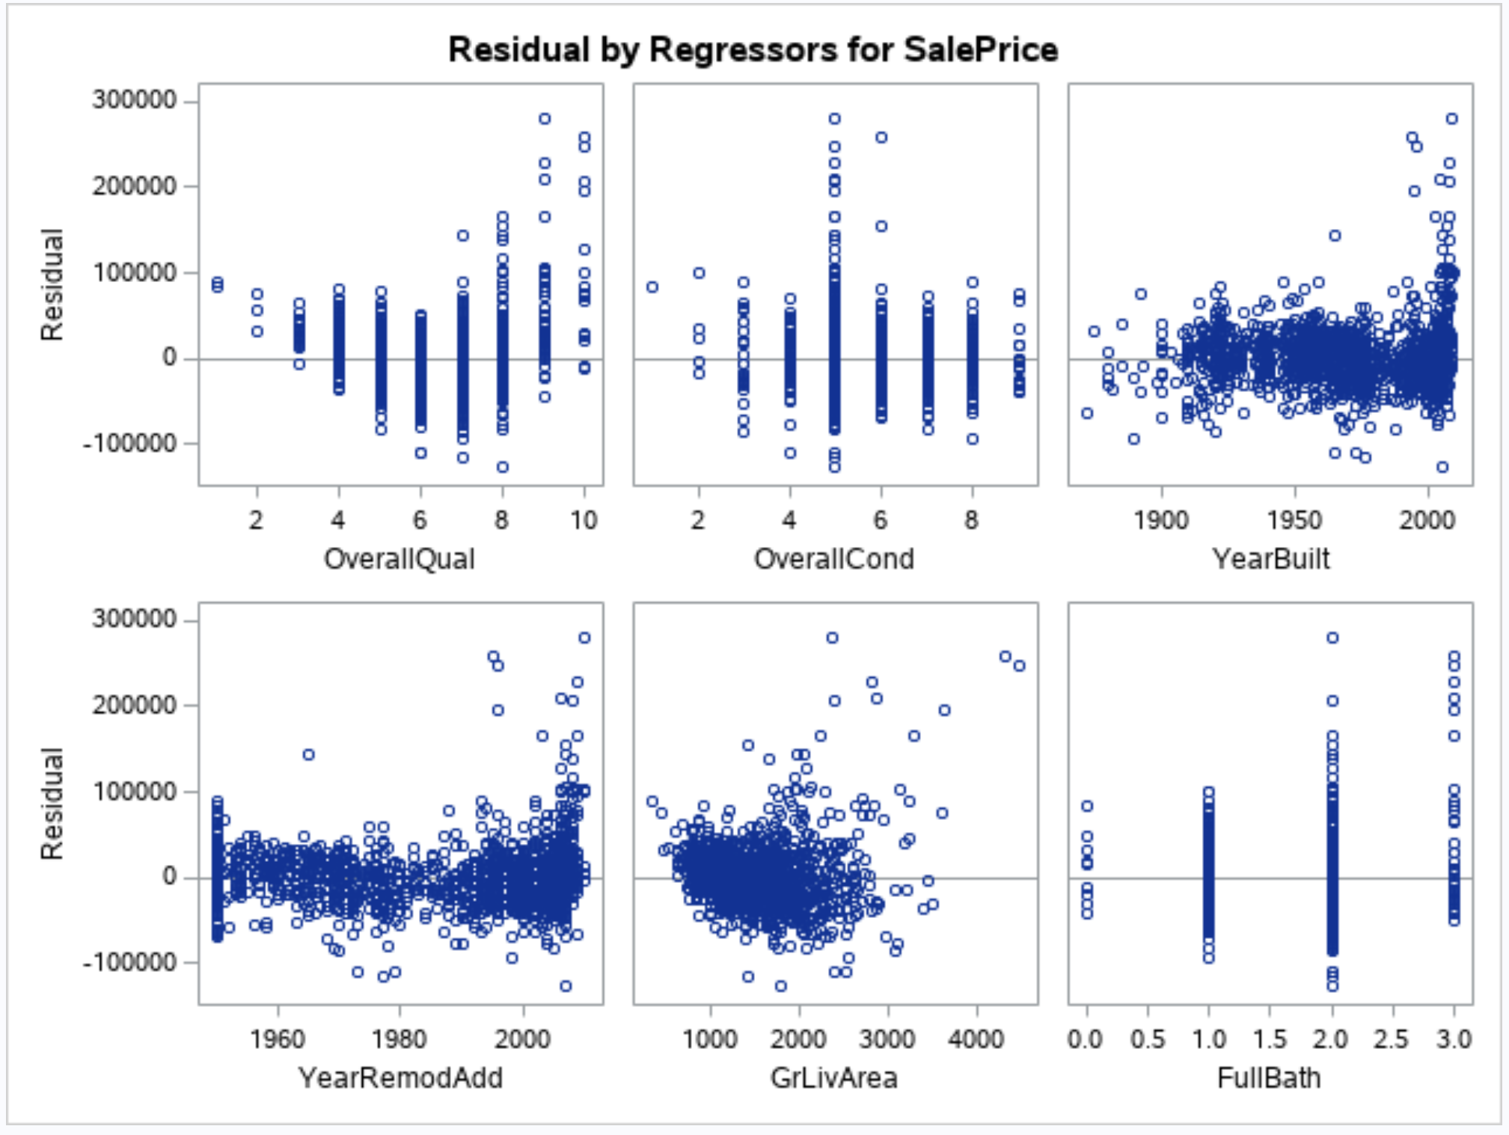 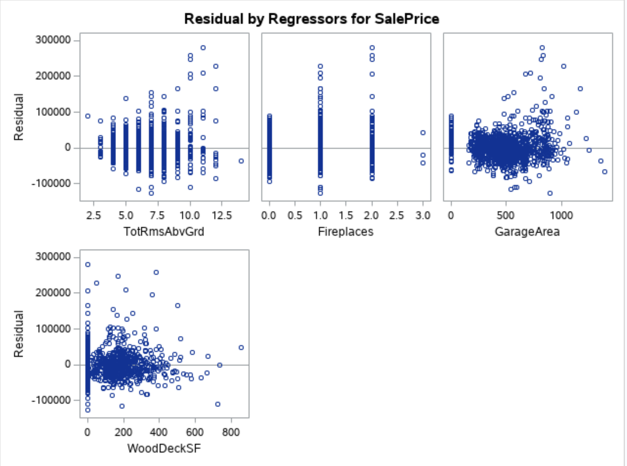

**PLOT 18**

**Stepwise Method:**

Build model5 with 12 numerical predictors:

proc reg data=trainames2Nooutlier;

model SalePrice = OverallQual OverallCond YearBuilt YearRemodAdd GrLivArea FullBath TotRmsAbvGrd

Fireplaces GarageCars GarageArea WoodDeckSF OpenPorchSF / selection=stepwise slentry=0.1 slstay=0.05 cp adjrsq aic bic partialr2 press sp vif; run;

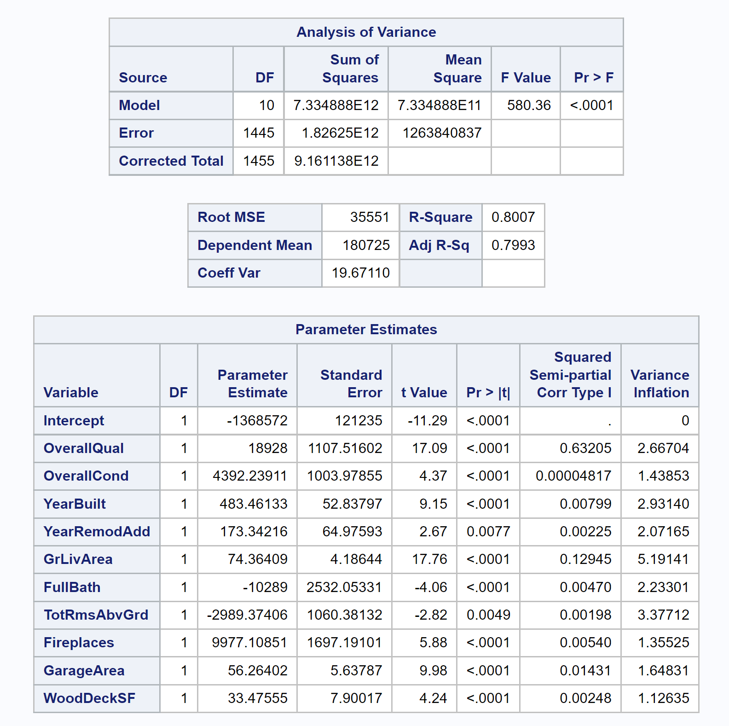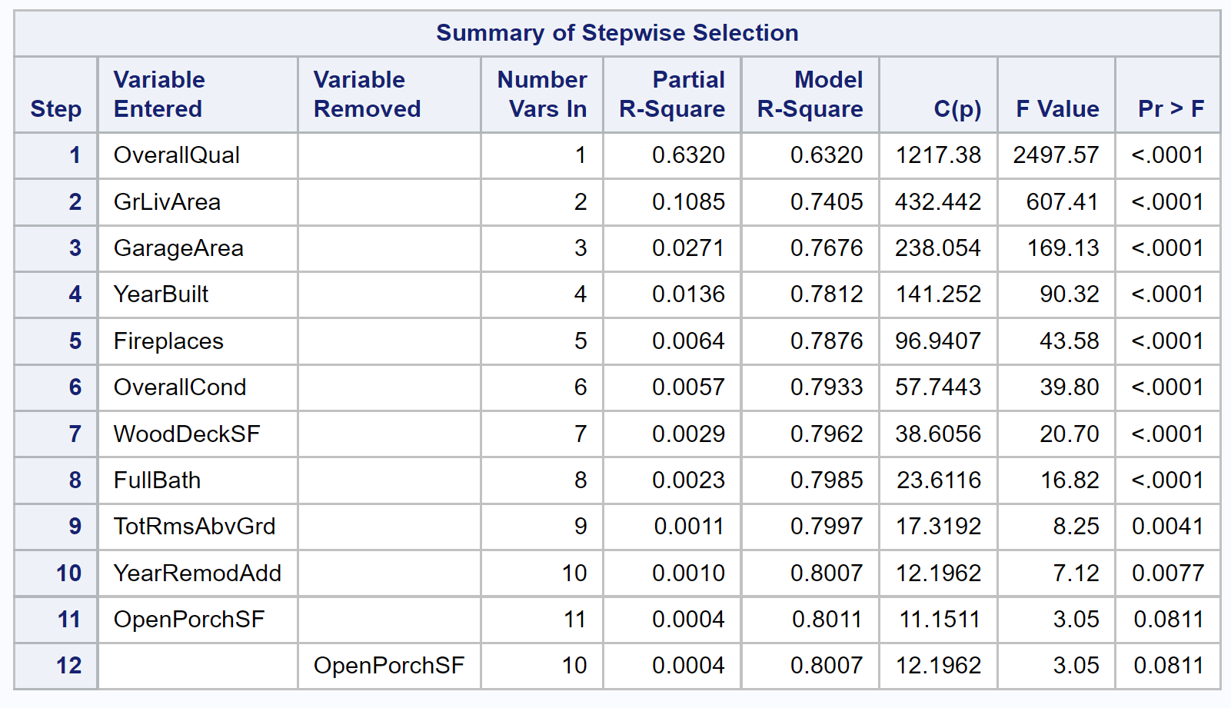

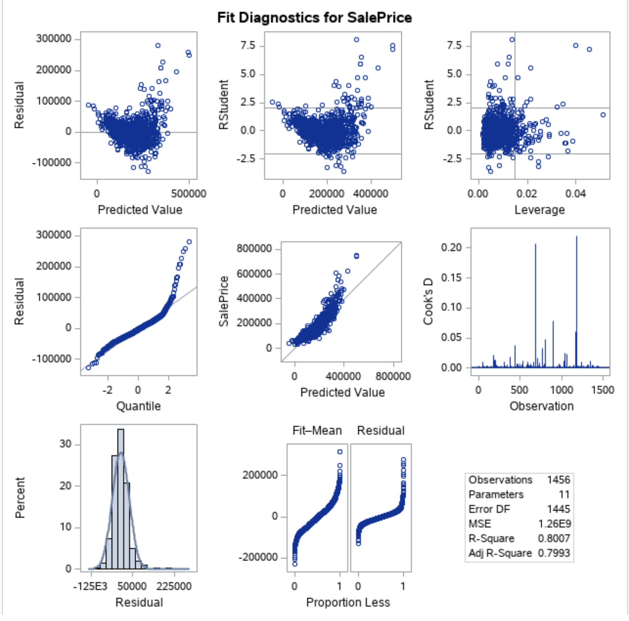

**PLOT 19**

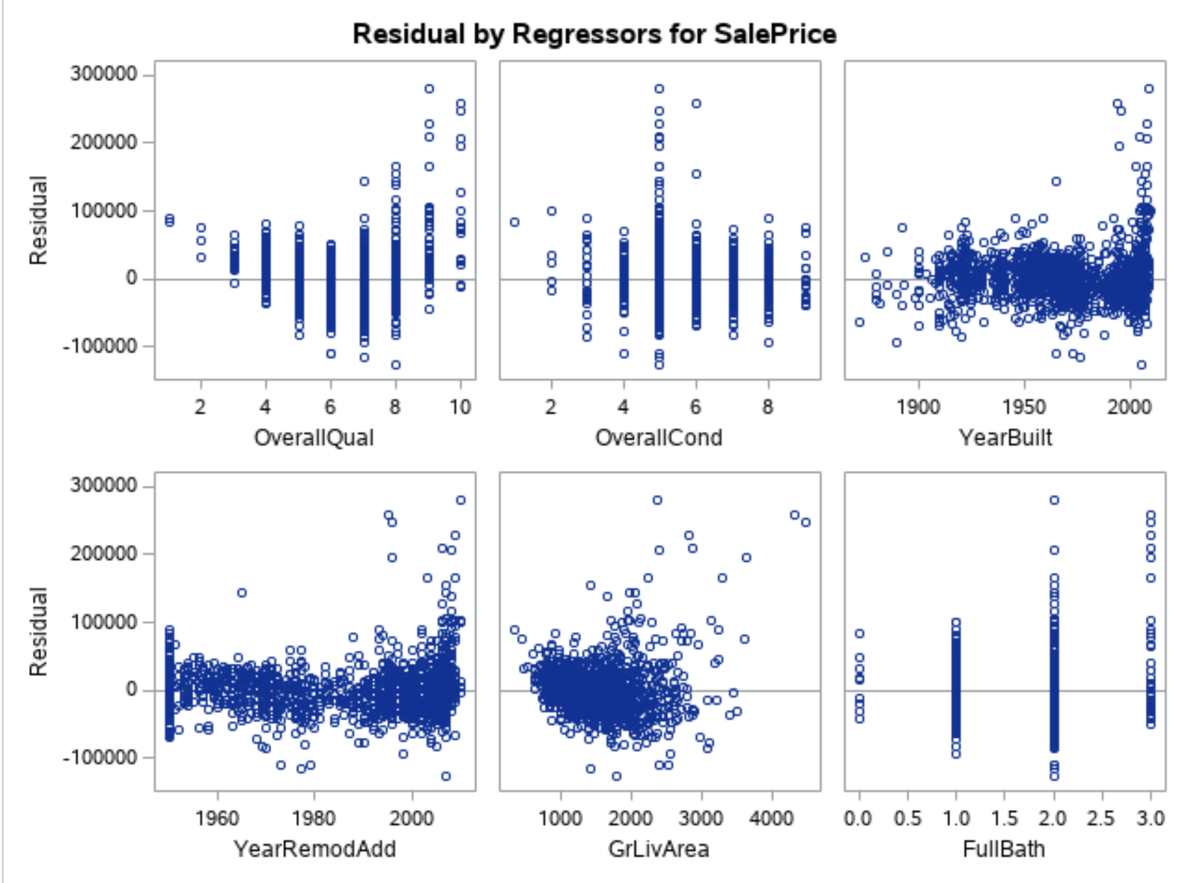

**PLOT 20**

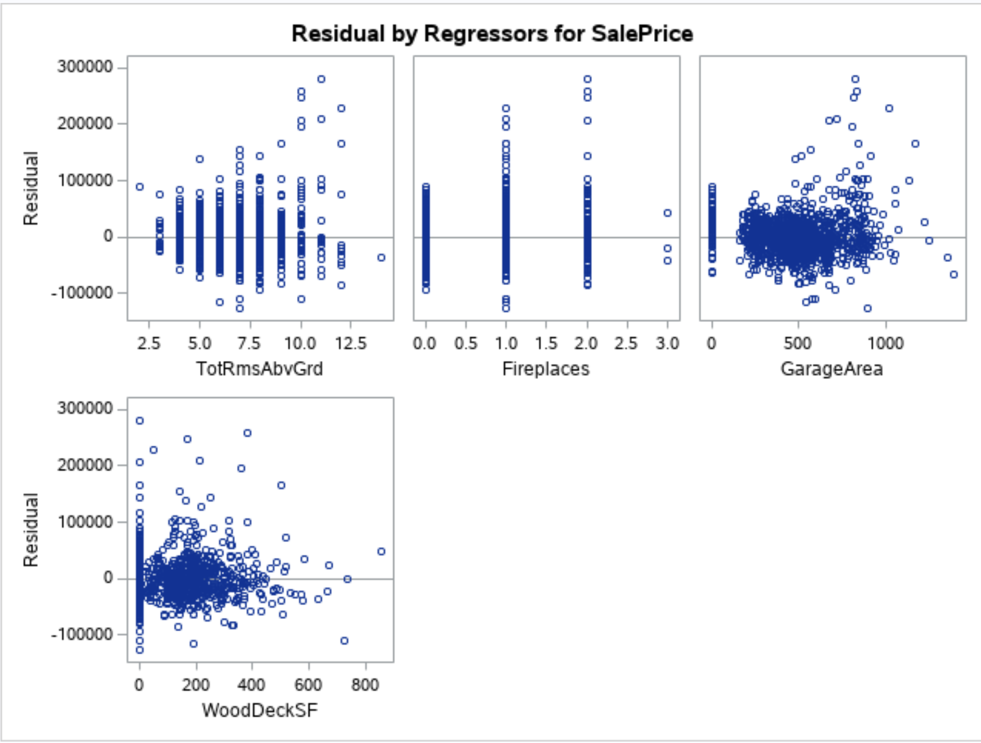

**PLOT 21**

Build model 6 with log transformation:

proc reg data=trainames2Nooutlier;

model logSalePrice = logOverallQual GrLivArea GarageArea YearBuilt / selection=stepwise slentry=0.1 slstay=0.05 cp adjrsq aic bic partialr2 press sp vif; run;

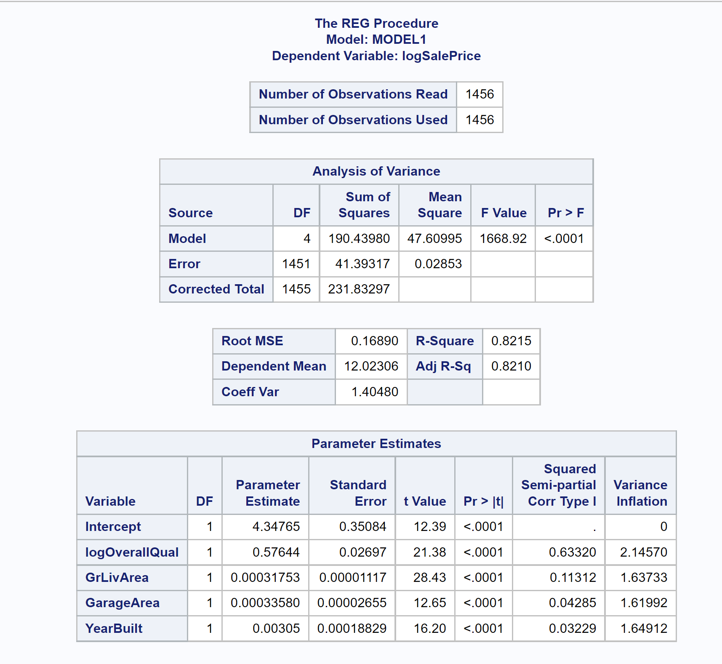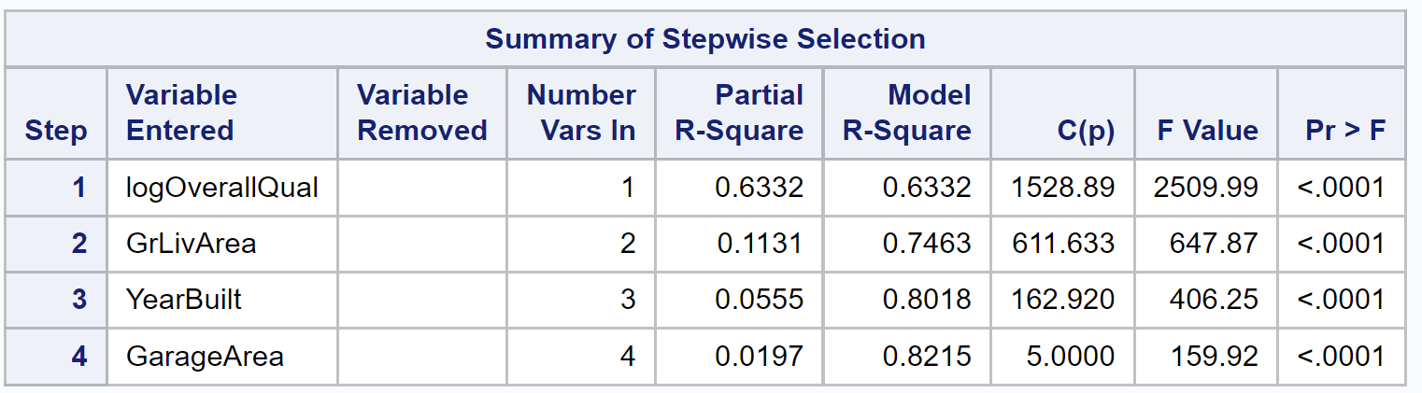

**Table 13**

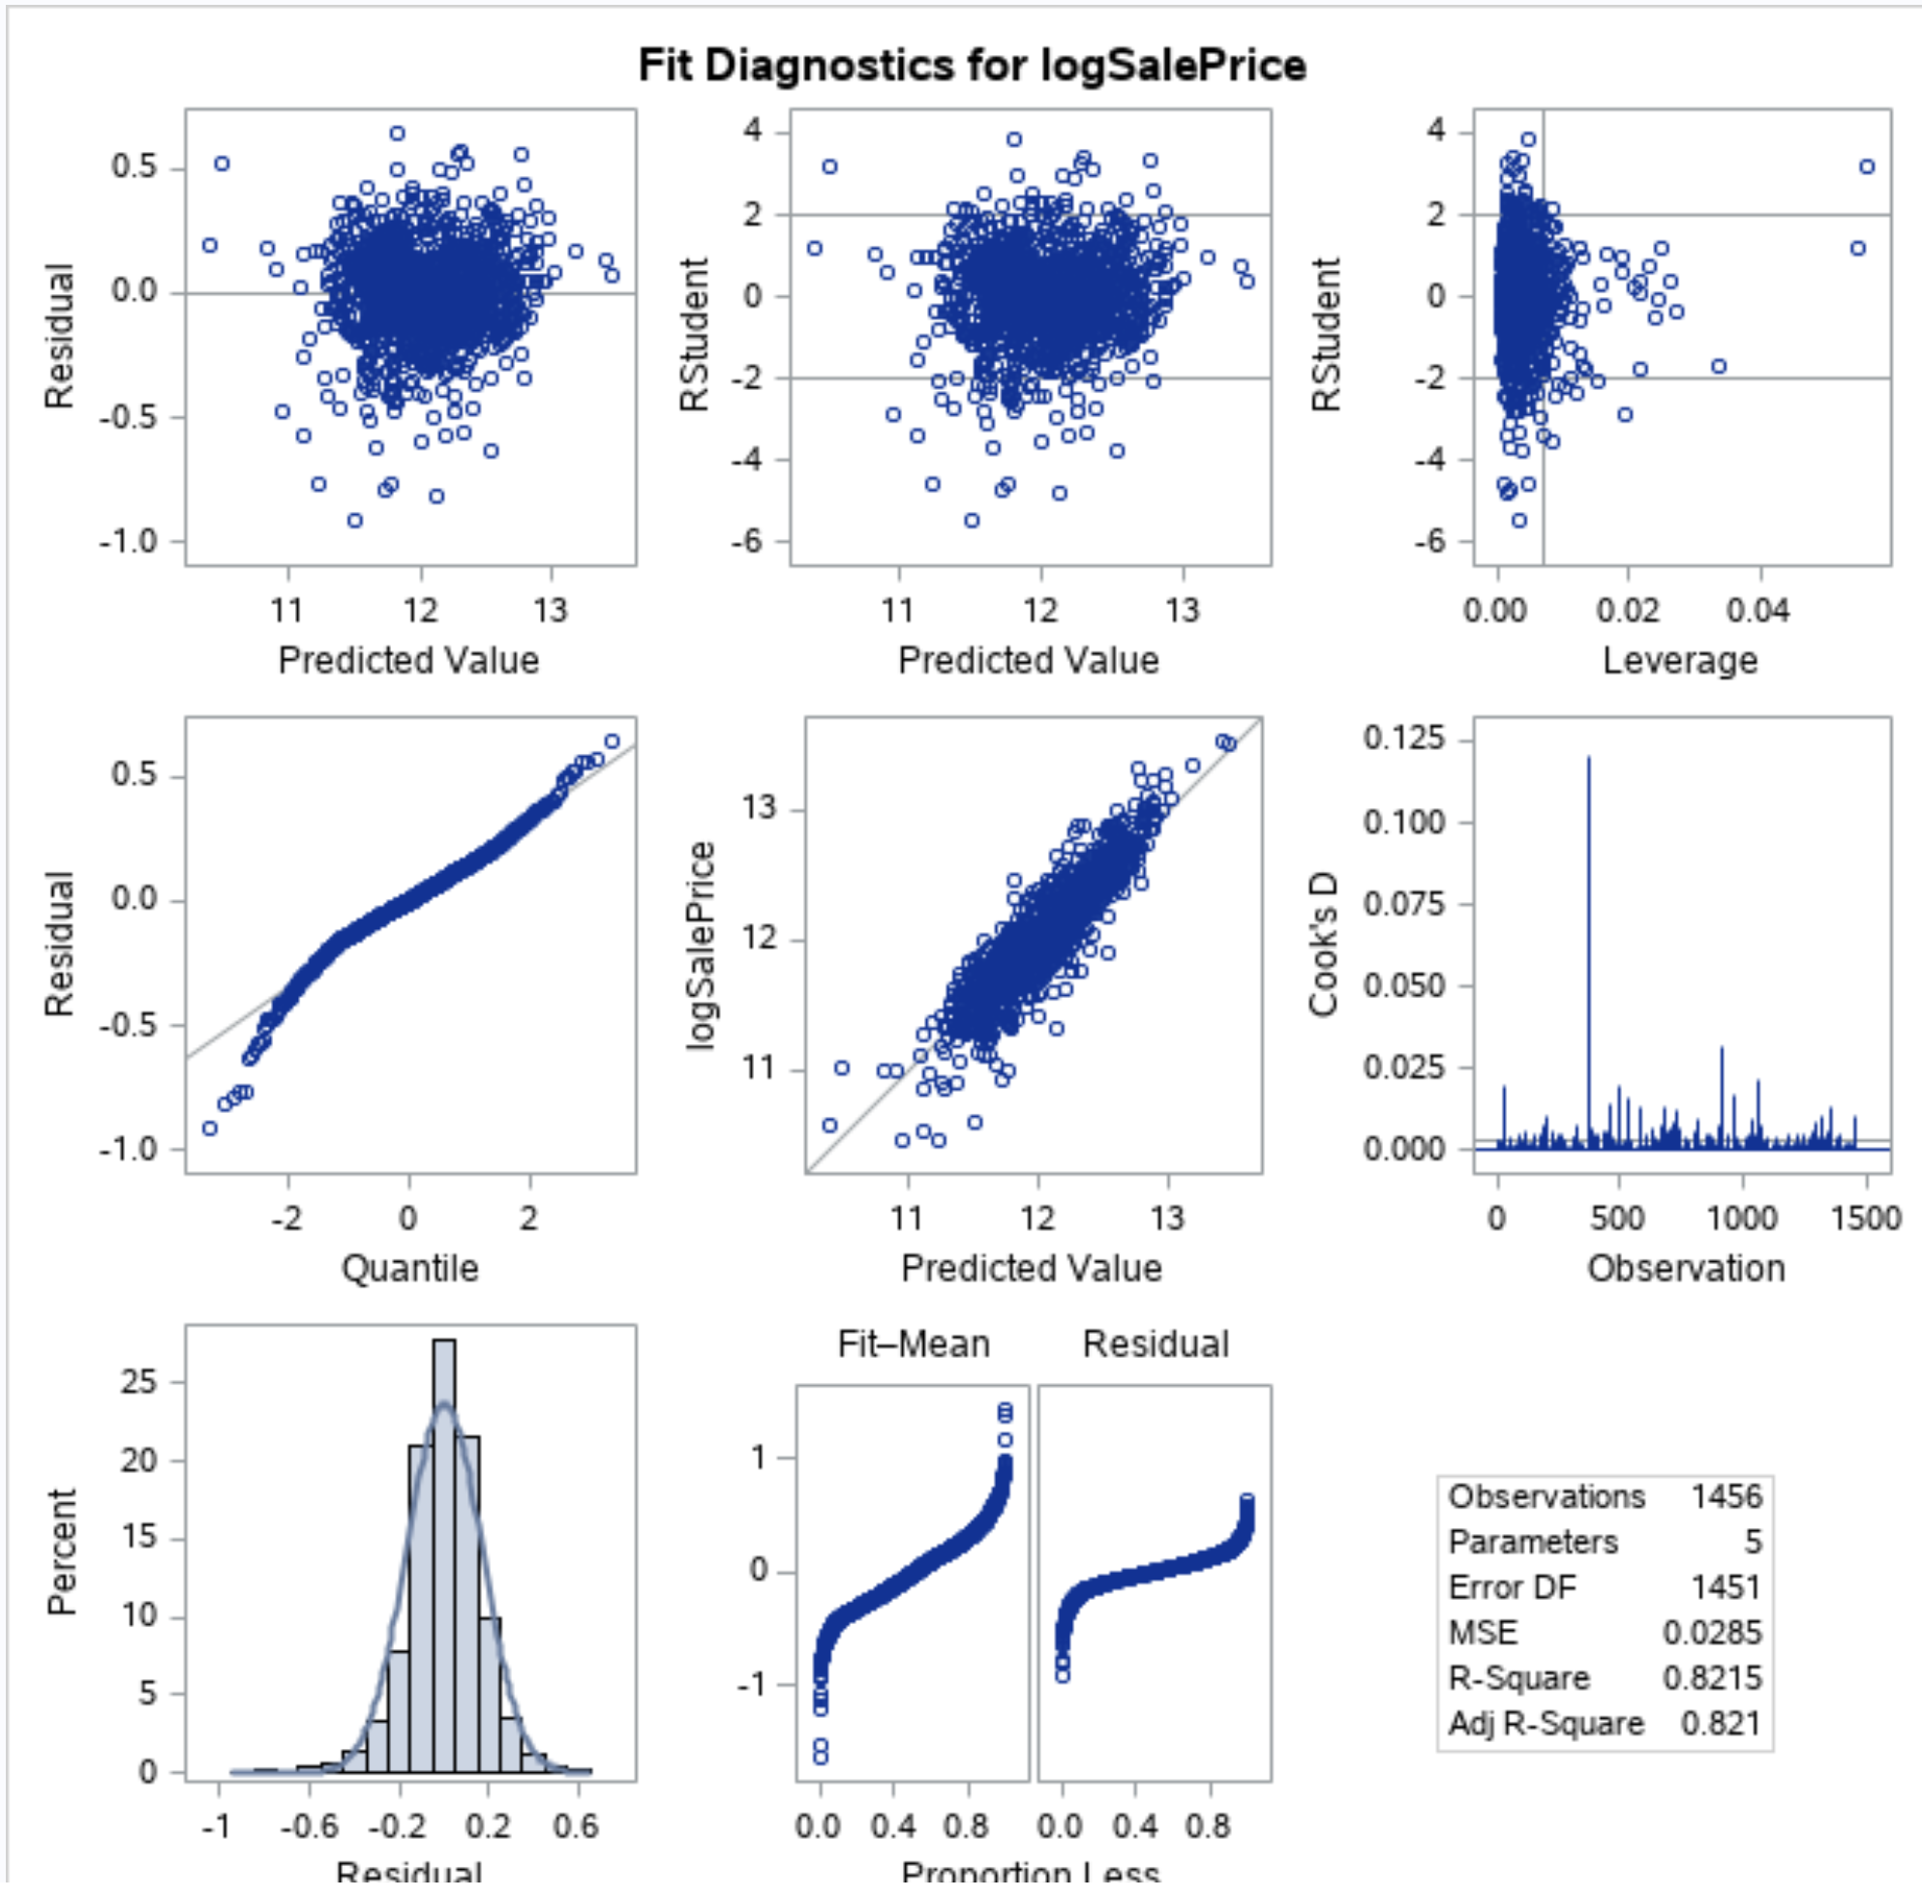

**PLOT 22**

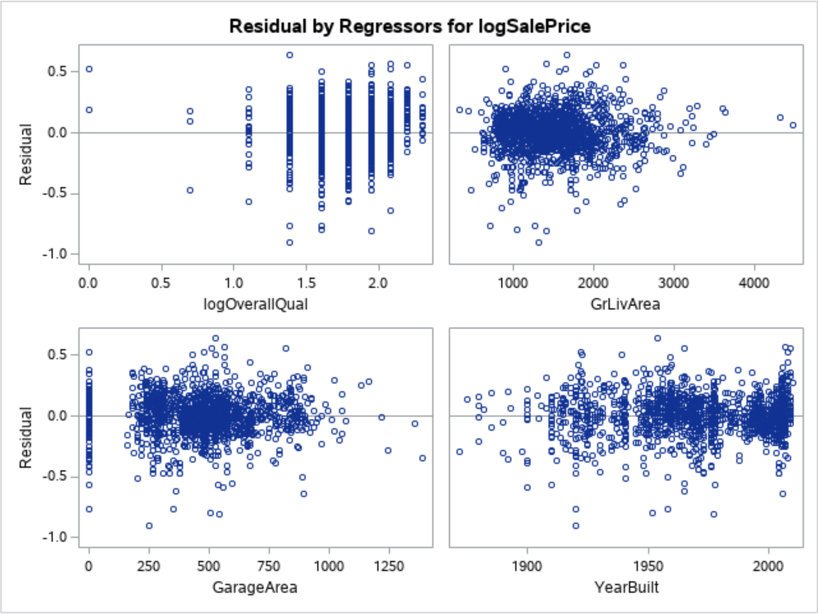

**PLOT 23**

**Custom Method:**

We will create a custom model with categorical variables added. We removing variables with NA's: LotFrontage MasVnrArea GarageYrBlt and variables with wrong name: 1stFlrSF 2ndFlrSF 3SsnPorch.

data trainAmes3;

set IMPORT;

keep Id MSSubClass LotArea OverallQual OverallCond YearBuilt YearRemodAdd BsmtFinSF1 BsmtFinSF2 BsmtUnfSF

LowQualFinSF GrLivArea BsmtFullBath BsmtHalfBath FullBath HalfBath BedroomAbvGr

KitchenAbvGr TotRmsAbvGrd Fireplaces GarageCars GarageArea WoodDeckSF OpenPorchSF EnclosedPorch ScreenPorch PoolArea MiscVal MoSold

YrSold Utilities LotConfig Neighborhood ExterQual BsmtQual HeatingQC KitchenQual FireplaceQu GarageQual

PoolQC Fence SaleType SaleCondition SalePrice;

run;

data trainAmes3NoOutlier;

set trainAmes3;

where Id ~= 643 AND Id ~= 725 AND Id ~= 1299 AND Id ~= 524; logSalePrice = log(SalePrice);

logOverallQual = log(OverallQual); logGrLivArea = log(GrLivArea);

if LotConfig="Inside" then LotConfig_num =5;

else if LotConfig="Corner" then LotConfig_num =4;

else if LotConfig="CulDSac" then LotConfig_num =3;

else if LotConfig="FR2" then LotConfig_num =2;

else if LotConfig="FR3" then LotConfig_num =1;

if Neighborhood="Blmngtn" then Neighborhood_num =25;

else if Neighborhood="Blueste" then Neighborhood_num =24;

else if Neighborhood="BrDale" then Neighborhood_num =23;

else if Neighborhood="BrkSide" then Neighborhood_num =22;

else if Neighborhood="ClearCr" then Neighborhood_num =21;

else if Neighborhood="CollgCr" then Neighborhood_num =20;

else if Neighborhood="Crawfor" then Neighborhood_num =19;

else if Neighborhood="Edwards" then Neighborhood_num =18;

else if Neighborhood="Gilbert" then Neighborhood_num =17;

else if Neighborhood="IDOTRR" then Neighborhood_num =16;

else if Neighborhood="MeadowV" then Neighborhood_num =15;

else if Neighborhood="Mitchel" then Neighborhood_num =14;

else if Neighborhood="Names" then Neighborhood_num =13;

else if Neighborhood="NoRidge" then Neighborhood_num =12;

else if Neighborhood="NPkVill" then Neighborhood_num =11;

else if Neighborhood="NridgHt" then Neighborhood_num =10;

else if Neighborhood="NWAmes" then Neighborhood_num =9;

else if Neighborhood="OldTown" then Neighborhood_num =8;

else if Neighborhood="SWISU" then Neighborhood_num =7;

else if Neighborhood="Sawyer" then Neighborhood_num =6;

else if Neighborhood="SawyerW" then Neighborhood_num =5;

else if Neighborhood="Somerst" then Neighborhood_num =4;

else if Neighborhood="StoneBr" then Neighborhood_num =3;

else if Neighborhood="Timber" then Neighborhood_num =2;

else if Neighborhood="Veenker" then Neighborhood_num =1;

if ExterQual="Ex" then ExterQual_num =5;

else if ExterQual="Gd" then ExterQual_num =4;

else if ExterQual="TA" then ExterQual_num =3;

else if ExterQual="Fa" then ExterQual_num =2;

else if ExterQual="Po" then ExterQual_num =1;

if BsmtQual="Ex" then BsmtQual_num =5;

else if BsmtQual="Gd" then BsmtQual_num =4;

else if BsmtQual="TA" then BsmtQual_num =3;

else if BsmtQual="Fa" then BsmtQual_num =2;

else if BsmtQual="Po" then BsmtQual_num =1;

else if BsmtQual="NA" then BsmtQual_num =0;

if HeatingQC="Ex" then HeatingQC_num =5;

else if HeatingQC="Gd" then HeatingQC_num =4;

else if HeatingQC="TA" then HeatingQC_num =3;

else if HeatingQC="Fa" then HeatingQC_num =2;

else if HeatingQC="Po" then HeatingQC_num =1;

if KitchenQual="Ex" then KitchenQual_num =5;

else if KitchenQual="Gd" then KitchenQual_num =4;

else if KitchenQual="TA" then KitchenQual_num =3;

else if KitchenQual="Fa" then KitchenQual_num =2;

else if KitchenQual="Po" then KitchenQual_num =1;

if FireplaceQu="Ex" then FireplaceQu_num =5;

else if FireplaceQu="Gd" then FireplaceQu_num =4;

else if FireplaceQu="TA" then FireplaceQu_num =3;

else if FireplaceQu="Fa" then FireplaceQu_num =2;

else if FireplaceQu="Po" then FireplaceQu_num =1;

else if FireplaceQu="NA" then FireplaceQu_num =0;

if GarageQual="Ex" then GarageQual_num =5;

else if GarageQual="Gd" then GarageQual_num =4;

else if GarageQual="TA" then GarageQual_num =3;

else if GarageQual="Fa" then GarageQual_num =2;

else if GarageQual="Po" then GarageQual_num =1;

else if GarageQual="NA" then GarageQual_num =0;

if PoolQC="Ex" then PoolQC_num =5;

else if PoolQC="Gd" then PoolQC_num =4;

else if PoolQC="TA" then PoolQC_num =3;

else if PoolQC="Fa" then PoolQC_num =2;

else if PoolQC="NA" then PoolQC_num =1;

if SaleCondition="Normal" then SaleCondition_num =6;

else if SaleCondition="Abnorml" then SaleCondition_num =5;

else if SaleCondition="AdjLand" then SaleCondition_num =4;

else if SaleCondition="Alloca" then SaleCondition_num =3;

else if SaleCondition="Family" then SaleCondition_num =2;

else if SaleCondition="Partial" then SaleCondition_num =1;

run;

proc contents data=trainAmes3NoOutlier;

run;

proc print data=trainAmes3NoOutlier;

run;

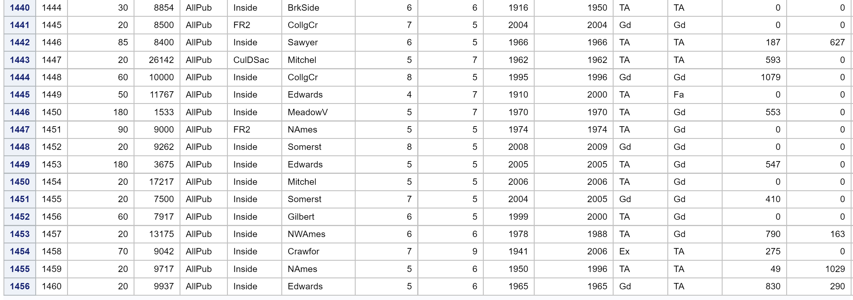

**Table 14**

**Forward selection with Cross Validation (CV)**

proc glmselect data=trainAmes3NoOutlier;

model logSalePrice = logOverallQual GrLivArea GarageArea YearBuilt OverallCond YearRemodAdd

FullBath TotRmsAbvGrd Fireplaces GarageCars WoodDeckSF OpenPorchSF LotConfig_num Neighborhood_num ExterQual_num BsmtQual_num HeatingQC_num KitchenQual_num FireplaceQu_num

GarageQual_num PoolQC_num SaleCondition_num

/selection=Forward(stop=cv) cvmethod=random(5) stats=adjrsq;

run;

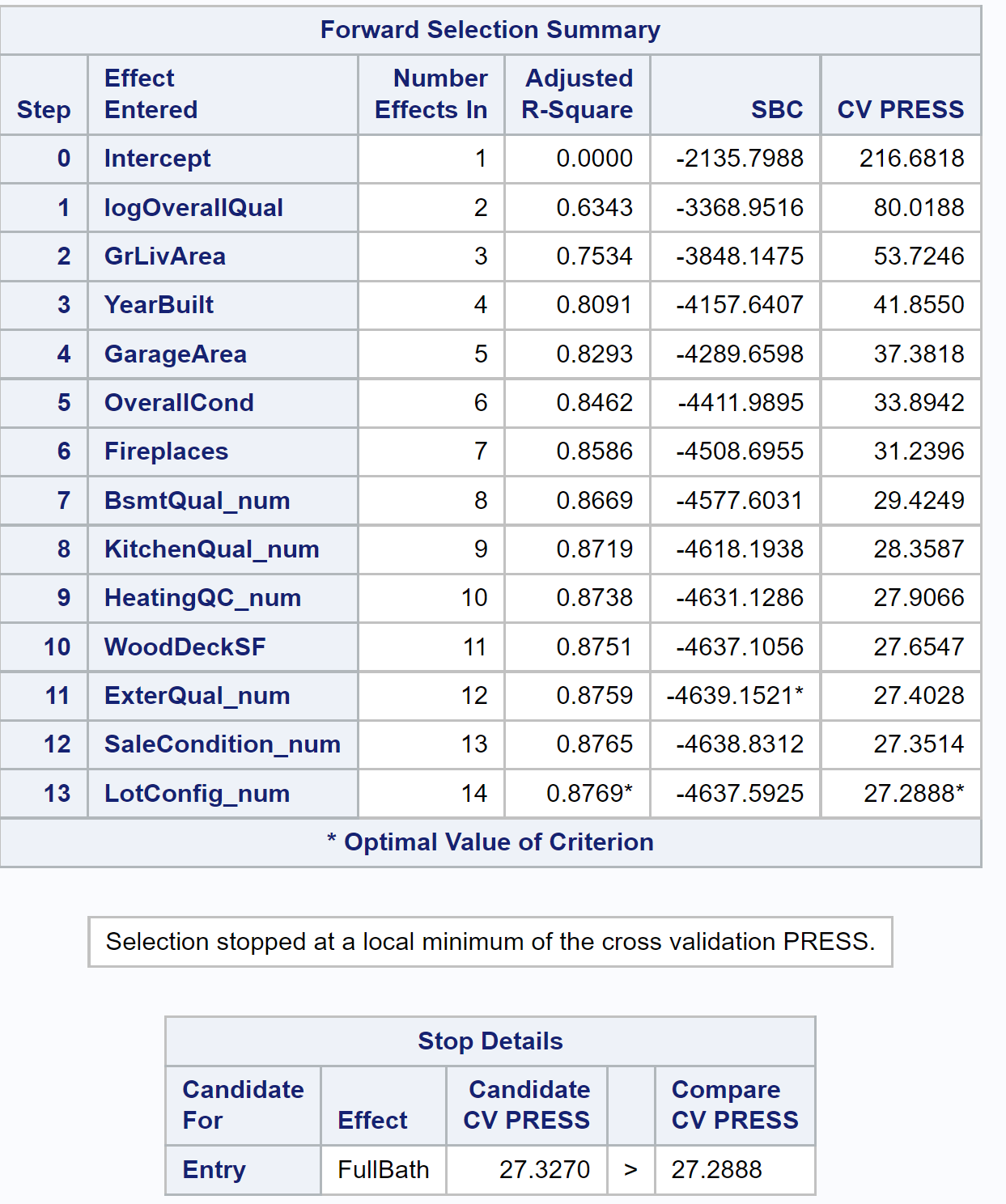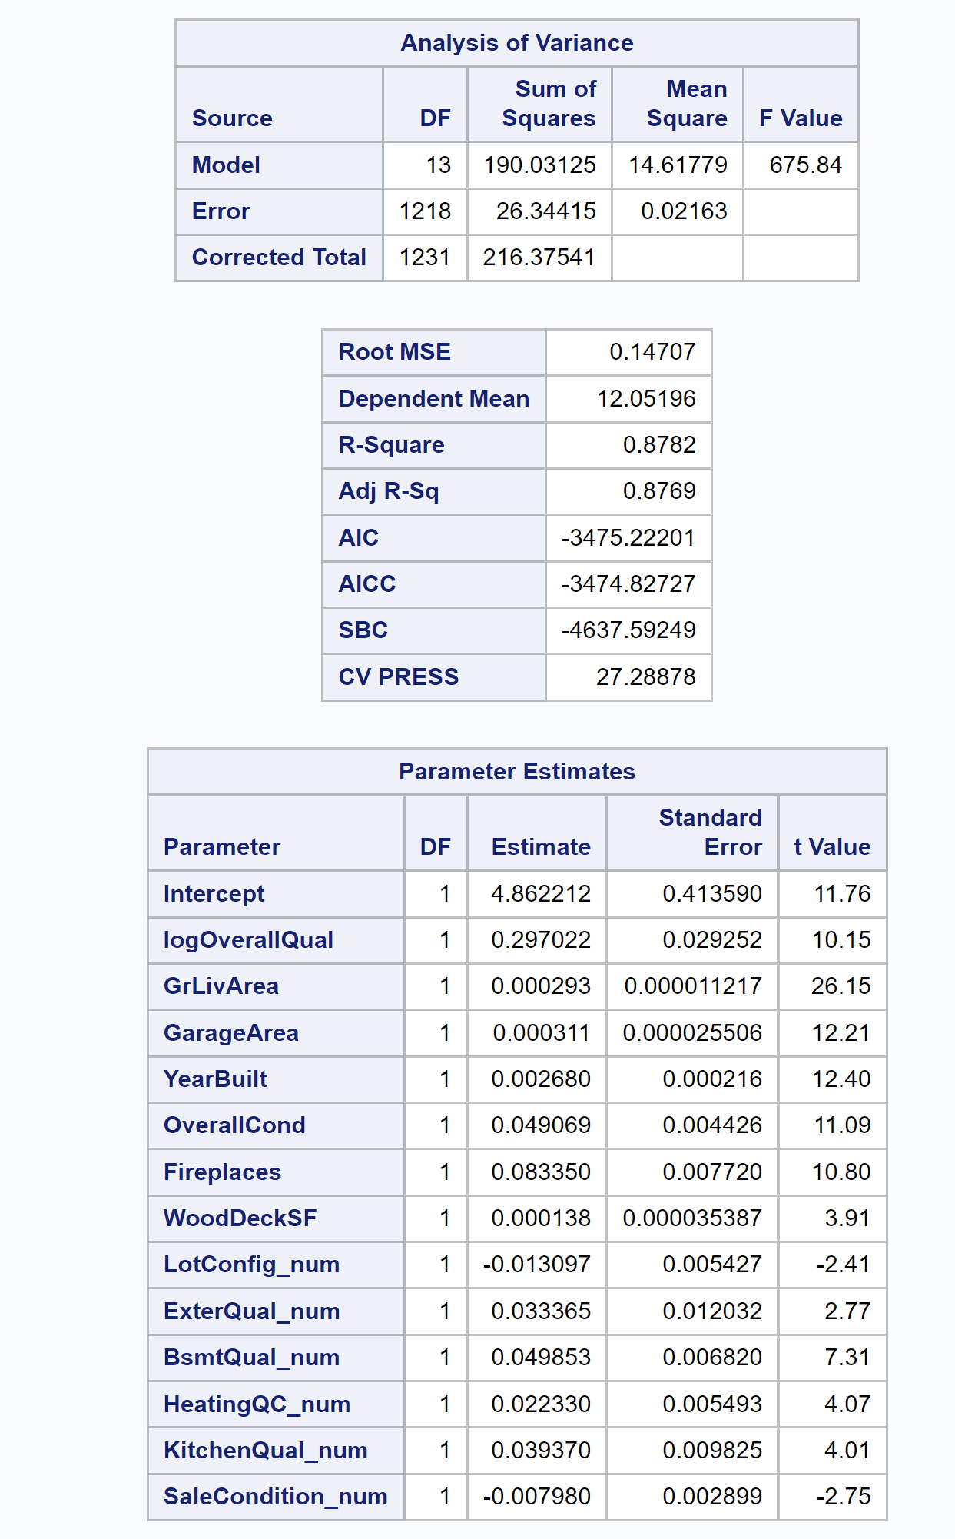

**Table 15**

**Backward selection with Cross Validation (CV):**

proc glmselect data=trainAmes3NoOutlier;

model logSalePrice = logOverallQual GrLivArea GarageArea YearBuilt OverallCond YearRemodAdd

FullBath TotRmsAbvGrd Fireplaces GarageCars WoodDeckSF OpenPorchSF LotConfig_num Neighborhood_num ExterQual_num BsmtQual_num HeatingQC_num KitchenQual_num FireplaceQu_num

GarageQual_num PoolQC_num SaleCondition_num

/selection=Backward(stop=cv) cvmethod=random(5) stats=adjrsq;

run;

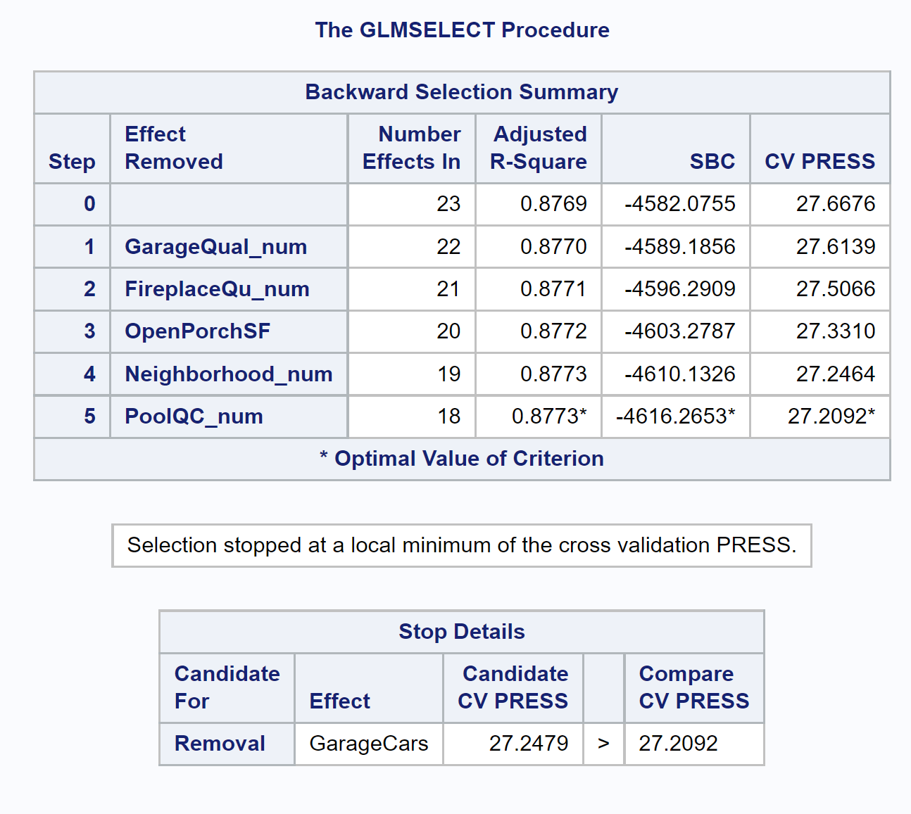 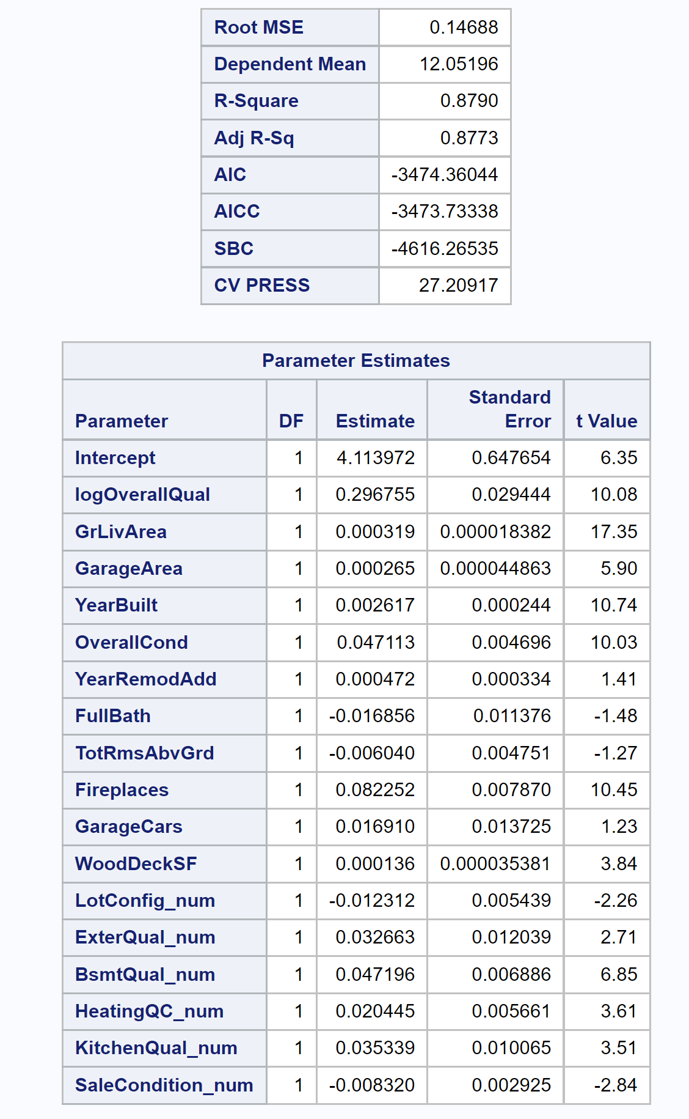

**Table 16**

**Stepwise selection with Cross Validation (CV):**

proc glmselect data=trainAmes3NoOutlier;

model logSalePrice = logOverallQual GrLivArea GarageArea YearBuilt OverallCond

YearRemodAdd

FullBath TotRmsAbvGrd Fireplaces GarageCars WoodDeckSF OpenPorchSF LotConfig_num Neighborhood_num ExterQual_num BsmtQual_num HeatingQC_num KitchenQual_num FireplaceQu_num

GarageQual_num PoolQC_num SaleCondition_num

/selection=Stepwise(stop=cv) cvmethod=random(5) stats=adjrsq;

run;

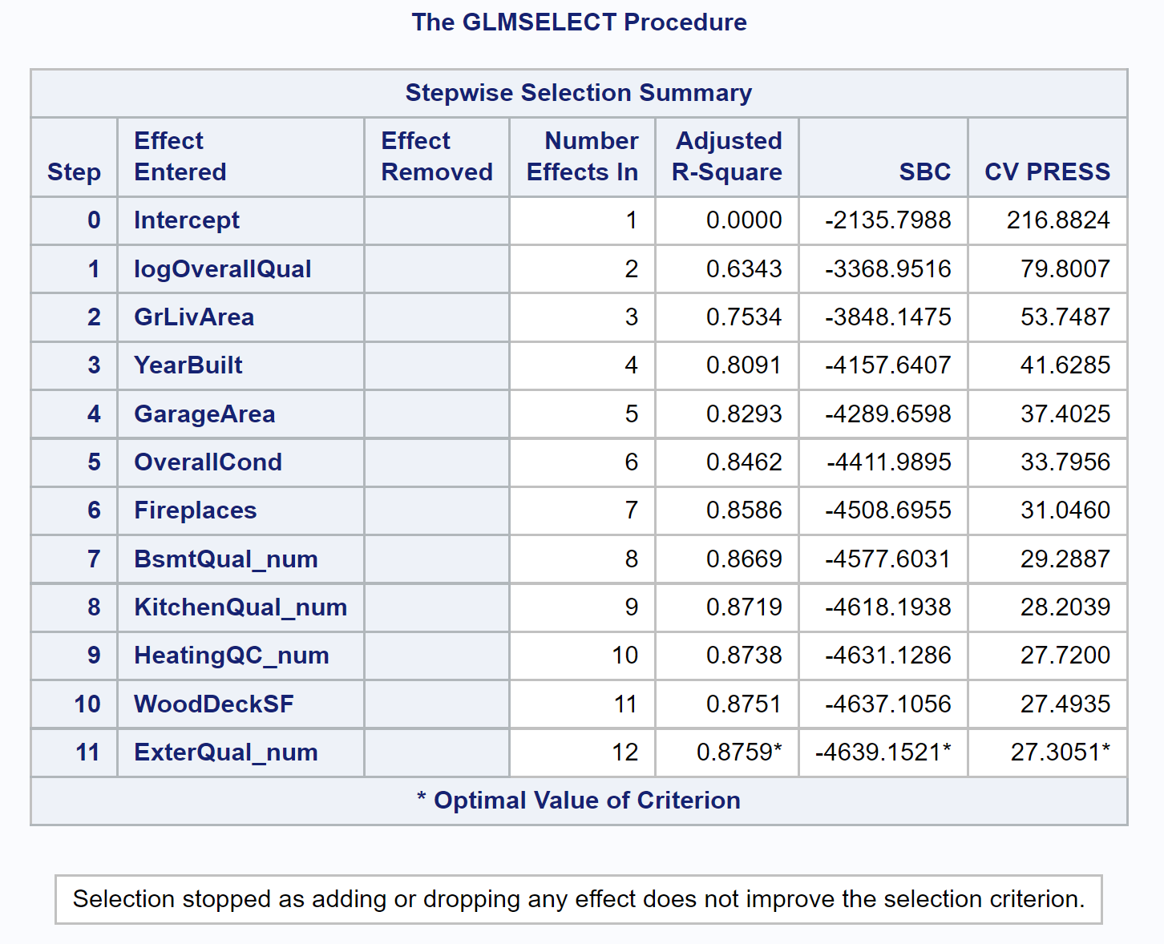 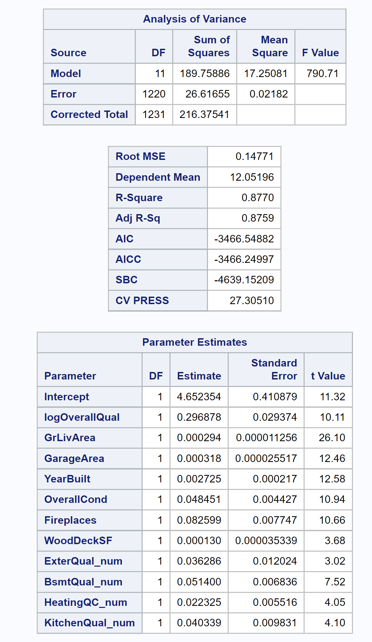

**Table 17**

**Custom selection with Cross Validation (CV):**

proc glmselect data=trainAmes3NoOutlier plots=all;

model logSalePrice = logOverallQual GrLivArea GarageArea YearBuilt OverallCond

YearRemodAdd

FullBath TotRmsAbvGrd Fireplaces GarageCars WoodDeckSF OpenPorchSF LotConfig_num Neighborhood_num ExterQual_num BsmtQual_num HeatingQC_num KitchenQual_num FireplaceQu_num

GarageQual_num PoolQC_num SaleCondition_num / selection=none;

output out=results p=Predict;

run;

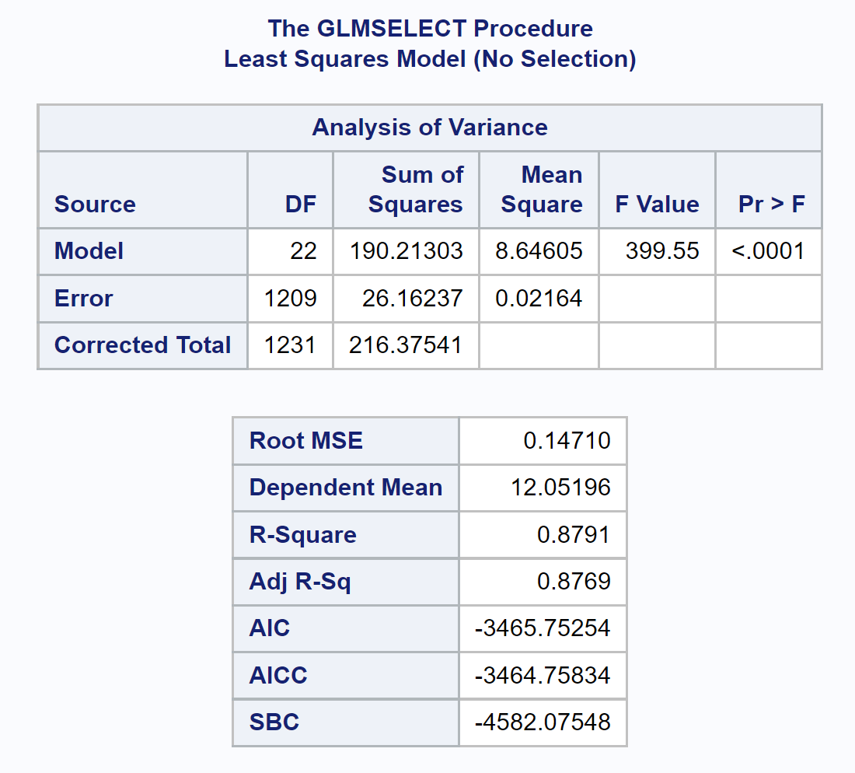

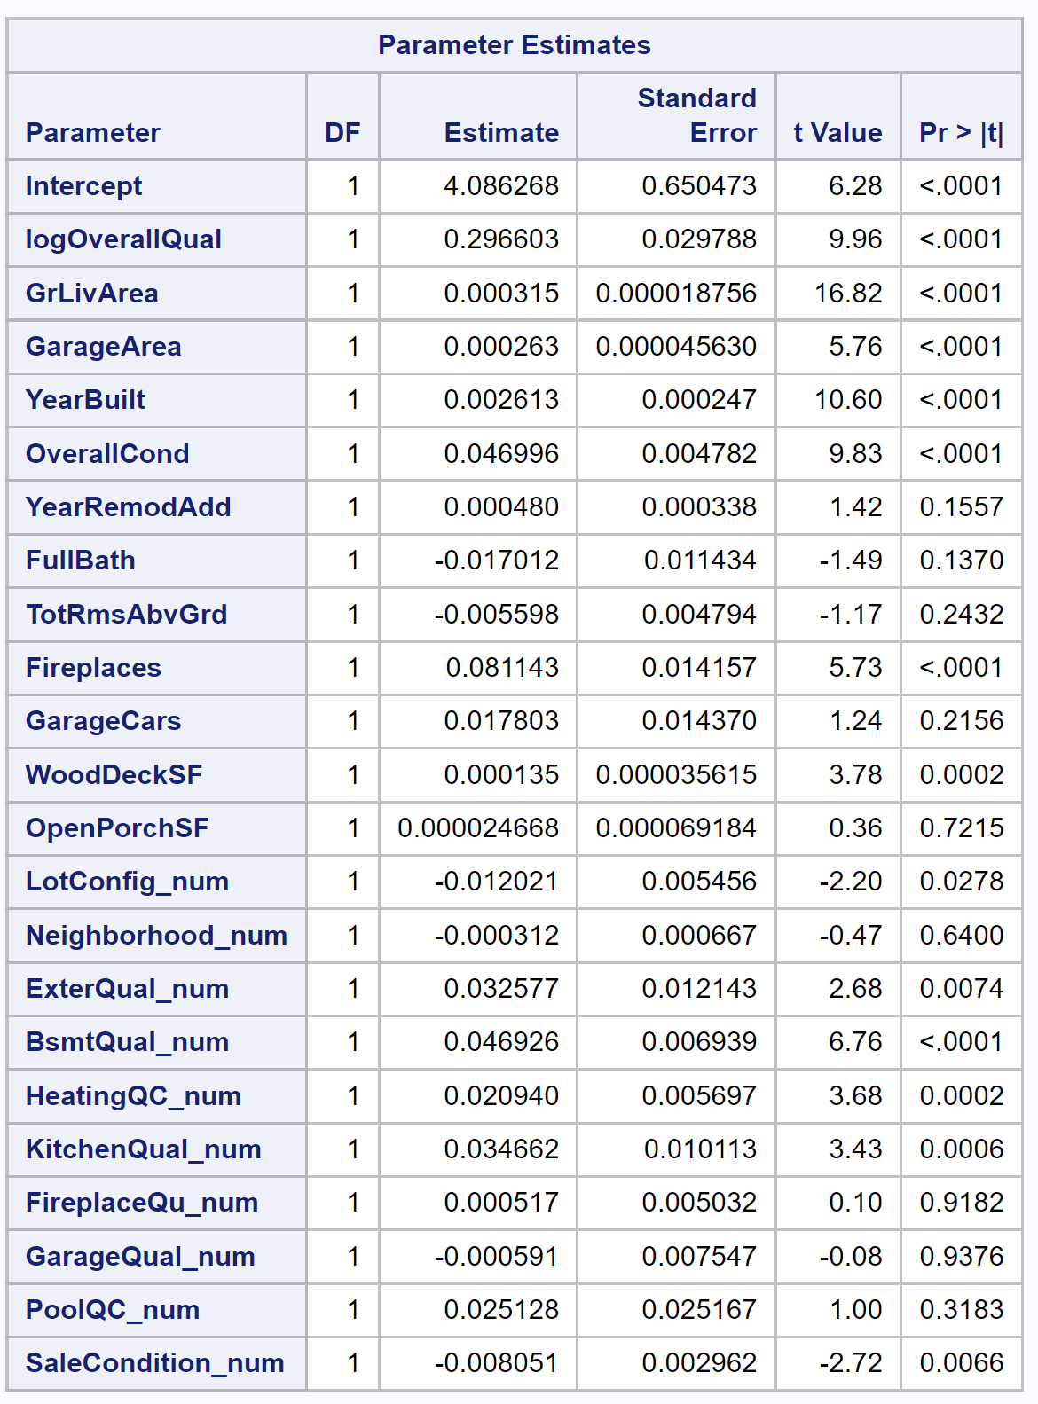

**Table 18**

**Prepare data for kaggle uploading:**

**Resulted in Place# Resulted in Place# 3260 and Kaggle Score 0.17575**

data test;

set IMPORT1;

if GarageArea='' then GarageArea=0; if GarageCars='' then GarageCars=0; if KitchenQual='NA' then KitchenQual='Po';

SalePrice = .; run;

data train2; set IMPORT test; run;

data train2Ames3; set train2;

keep Id OverallQual GrLivArea GarageArea YearBuilt OverallCond YearRemodAdd FullBath TotRmsAbvGrd Fireplaces GarageCars WoodDeckSF OpenPorchSF LotConfig Neighborhood ExterQual

BsmtQual HeatingQC KitchenQual FireplaceQu GarageQual PoolQC SaleCondition SalePrice; run;

data train2Ames3NoOutlier; set train2Ames3;

where Id ~= 643 AND Id ~= 725 AND Id ~= 1299 AND Id ~= 524; logSalePrice = log(SalePrice); logOverallQual = log(OverallQual); logGrLivArea = log(GrLivArea); /** 10 Categorical => Numeric **/

/** LotConfig, Neighborhood, ExterQual, BsmtQual, HeatingQC, KitchenQual,

FireplaceQu, GarageQual, PoolQC, SaleCondition **/

/*** LotConfig => LotConfig_num ***/

if LotConfig="Inside" then LotConfig_num =5; else if LotConfig="Corner" then LotConfig_num =4; else if LotConfig="CulDSac" then LotConfig_num =3; else if LotConfig="FR2" then LotConfig_num =2; else if LotConfig="FR3" then LotConfig_num =1;

/*** Neighborhood => Neighborhood_num ***/ if Neighborhood="Blmngtn" then Neighborhood_num =25; else if Neighborhood="Blueste" then Neighborhood_num =24; else if Neighborhood="BrDale" then Neighborhood_num =23; else if Neighborhood="BrkSide" then Neighborhood_num =22; else if Neighborhood="ClearCr" then Neighborhood_num =21; else if Neighborhood="CollgCr" then Neighborhood_num =20; else if Neighborhood="Crawfor" then Neighborhood_num =19; else if Neighborhood="Edwards" then Neighborhood_num =18; else if Neighborhood="Gilbert" then Neighborhood_num =17; else if Neighborhood="IDOTRR" then Neighborhood_num =16; else if Neighborhood="MeadowV" then Neighborhood_num =15; else if Neighborhood="Mitchel" then Neighborhood_num =14; else if Neighborhood="NAmes" then Neighborhood_num =13; else if Neighborhood="NoRidge" then Neighborhood_num =12; else if Neighborhood="NPkVill" then Neighborhood_num =11; else if Neighborhood="NridgHt" then Neighborhood_num =10; else if Neighborhood="NWAmes" then Neighborhood_num =9; else if Neighborhood="OldTown" then Neighborhood_num =8; else if Neighborhood="SWISU" then Neighborhood_num =7; else if Neighborhood="Sawyer" then Neighborhood_num =6; else if Neighborhood="SawyerW" then Neighborhood_num =5; else if Neighborhood="Somerst" then Neighborhood_num =4; else if Neighborhood="StoneBr" then Neighborhood_num =3; else if Neighborhood="Timber" then Neighborhood_num =2; else if Neighborhood="Veenker" then Neighborhood_num =1;

/*** ExterQual => ExterQual_num ***/ if ExterQual="Ex" then ExterQual_num =5; else if ExterQual="Gd" then ExterQual_num =4; else if ExterQual="TA" then ExterQual_num =3; else if ExterQual="Fa" then ExterQual_num =2; else if ExterQual="Po" then ExterQual_num =1;

/*** BsmtQual => BsmtQual_num ***/

if BsmtQual="Ex" then BsmtQual_num =6; else if BsmtQual="Gd" then BsmtQual_num =5; else if BsmtQual="TA" then BsmtQual_num =4;

else if BsmtQual="Fa" then BsmtQual_num =3; else if BsmtQual="Po" then BsmtQual_num =2; else if BsmtQual="NA" then BsmtQual_num =1;

/*** HeatingQC => HeatingQC_num ***/ if HeatingQC="Ex" then HeatingQC_num =5; else if HeatingQC="Gd" then HeatingQC_num =4; else if HeatingQC="TA" then HeatingQC_num =3; else if HeatingQC="Fa" then HeatingQC_num =2; else if HeatingQC="Po" then HeatingQC_num =1;

/*** KitchenQual => KitchenQual_num ***/ if KitchenQual="Ex" then KitchenQual_num =5; else if KitchenQual="Gd" then KitchenQual_num =4; else if KitchenQual="TA" then KitchenQual_num =3; else if KitchenQual="Fa" then KitchenQual_num =2; else if KitchenQual="Po" then KitchenQual_num =1;

/*** FireplaceQu => FireplaceQu_num ***/ if FireplaceQu="Ex" then FireplaceQu_num =6; else if FireplaceQu="Gd" then FireplaceQu_num =5; else if FireplaceQu="TA" then FireplaceQu_num =4; else if FireplaceQu="Fa" then FireplaceQu_num =3; else if FireplaceQu="Po" then FireplaceQu_num =2; else if FireplaceQu="NA" then FireplaceQu_num =1;

if GarageQual="Ex" then GarageQual_num =6; else if GarageQual="Gd" then GarageQual_num =5; else if GarageQual="TA" then GarageQual_num =4; else if GarageQual="Fa" then GarageQual_num =3; else if GarageQual="Po" then GarageQual_num =2; else if GarageQual="NA" then GarageQual_num =1;

if PoolQC="Ex" then PoolQC_num =5; else if PoolQC="Gd" then PoolQC_num =4; else if PoolQC="TA" then PoolQC_num =3; else if PoolQC="Fa" then PoolQC_num =2; else if PoolQC="NA" then PoolQC_num =1;

if SaleCondition="Normal" then SaleCondition_num =6; else if SaleCondition="Abnorml" then SaleCondition_num =5;

else if SaleCondition="AdjLand" then SaleCondition_num =4;

else if SaleCondition="Alloca" then SaleCondition_num =3; else if SaleCondition="Family" then SaleCondition_num =2; else if SaleCondition="Partial" then SaleCondition_num =1; run;

proc glmselect data=train2Ames3NoOutlier;

model logSalePrice = logOverallQual | GrLivArea GarageArea | YearBuilt | OverallCond | YearRemodAdd

FullBath TotRmsAbvGrd Fireplaces GarageCars WoodDeckSF OpenPorchSF LotConfig_num Neighborhood_num ExterQual_num BsmtQual_num HeatingQC_num KitchenQual_num FireplaceQu_num

GarageQual_num PoolQC_num SaleCondition_num

/selection=Backward(stop=cv) cvmethod=random(5) stats=adjrsq; output out= results p= predict; run;

proc print data=train2Ames3NoOutlier; where Id=1461; run;

data results2;

set results;

where id > 1460;

logSalePrice = predict;

SalePrice = 2.7182818284590452353602874713527**logSalePrice; keep id SalePrice;

proc print data=results2; run;

proc means data=results2; var SalePrice; run;

